Central Iowa Local Workforce Area
WIOA Local Plan
PY24-27
July 1, 2024, to June 30, 2028

Index
Index Description | Page
Section 1: Infrastructure | 4
- Local Workforce Development Area (LWDA) Name | 4
- Counties in Central Iowa Workforce Development | 4
- Central Iowa Workforce Development Board Members | 5
- Central Iowa Workforce Development Chief Elected Officials | 5
- Central Iowa Workforce Development Board Subcommittees | 5
- Central Iowa Workforce Development Board Fiscal Agent | 6
- Central Iowa Workforce Development Area Staff | 6
- WIOA Title I: Adult and Dislocated Worker Services Provider | 6
- WIOA Title I: Youth and Young Adult Services Provider | 7
- Office locations in Central Iowa Workforce Development Area | 7
- One-Stop Operator | 7
- Process For Submitting the Central Iowa Workforce Development Board Local Plan | 8
Section 2: Strategic Planning Elements | 9
- Economic Analysis: | 9
- Workforce Analysis: | 16
- Workforce Development, Education and Training Analysis | 25
- Central Iowa Workforce Development Board Vision | 29
- Strategies to Deliver and Work with Core Partners and Align Resources | 29
Section 3: IowaWORKS System Coordination | 31
- Workforce Development System Programs and Process to Implement and Support the State Strategies | 31
- Central Iowa Workforce Development Board and Core Partnership | 34
- Central Iowa Workforce Development Board’s Coordination of Investment activities with economic development partners. | 38
- One-Stop Delivery System | 39
- Description and Assessment of Employment and training activities Title I Adult and Dislocated Worker | 41
- Process to Coordinate Statewide and Local Workforce Investment Rapid Response Activities | 42
- The type and availability of youth workforce investment activities in the local area. | 42
- Coordination Process of Secondary and postsecondary education programs and activities | 44
- Coordination Process for transportation for Services | 45
- Process Plans to Maximize and Not Duplicate Services in the One-Stop Delivery System | 45
- Process to Coordinate and Review WIOA Title I workforce investment activities with WIOA | 46
- Memorandum of Understanding among partners | 46
- Process for WIOA Title I Service Provider Services. | 47
- Levels of performance for indicators of performance PY 24-PY25 | 47
- Process of Improvement for CIWDB – N/A | 51
- Process for Provision and Use of Individualized Training Accounts (ITAs) | 52
- Process for Public Review of Plan | 53
- Process of Technology-Integrated Case Management | 54
- Process will ensure priority of service for the WIOA Title I-B Adult career and training services | 55
- Veterans' priority of service | 55
- Assurances of Submission: Procedures and Policies are on Local Area Website | 56

SECTION 1 – INFRASTRUCTURE
A description of the local workforce development system in the local area.
- Describe the local workforce delivery system in the local workforce development area (LWDA), including the following:
  - Name of the LWDA:
  - Identification of the counties included in the LWDA:
  - A roster of all LWDB members, including the organization representing and title/role and the city/county each is from, and identification of the LWDB Chairperson
  - Identification of Subcommittees of the LWDB and the chair of each
  - Identification of the Fiscal Agent (entity responsible for disbursal of Title I grant funds)
  - Identification of all LWDB Staff and brief description of their role(s)
  - Identification of the competitively selected WIOA Title I Adult, Dislocated Worker, and Youth service providers
  - Identification of the One-Stop Operator for the local area
  - Identification of the office locations in the local area
  - A description of the process used to draft the local plan

CENTRAL IOWA WORKFORCE DEVELOPMENT AREA
COUNTIES:
Boone, Dallas, Jasper, Madison, Marion, Polk, Story and Warren
CHIEF ELECTED OFFICIALS representing the Local Workforce Area (1/1/24)
Boone County – Erich Kretzinger
Dallas County – Mark Hanson
Jasper County – Doug Cupples
Madison County – Heather Stancil
Marion County – Kisha Jahner
Polk County – Steve Van Oort
Story County – Lisa Heddens
Warren County – Darren Heater

CENTRAL IOWA LOCAL BOARD MEMBERS (1/1/24)
Name |  | Business/ Employer | Job Title | County of Residence
William | Berning | Iowa Workforce Development | Title III Operations Manager | Polk
Kathleen | Davis | Iowa Vocational Rehabilitation Services | Rehabilitation Supervisor | Polk
Rob | Denson | DMACC | President | Polk
Matt | Gaalaas | Wells Fargo | Senior Business Execution | Polk
Tom | Hayes | South Central Iowa Federation of Labor | Chapter Vice President | Dallas
Jim | Keck | Waldinger | Project Manager | Polk
Amy | Landas | Vision Bank | Boone County Market President | Boone
Jeremy | Lindquist | Plumbers and Steamfitters LU 33 | Training Director | Polk
Marcanne | Lynch | Mainstream Living | Director of Human Resources | Polk
Paula | Martinez | South Central Iowa Federation of Labor | President | Warren
Abigail | Miller | AgCertain | Mgr,Client and Business Services | Story
Lana | Pol | Geetings, Inc. | Owner | Marion
Michelle | Seibert | United Way | Economic Opportunity Officer | Polk
Jenae | Sikkink | Greater Des Moines Partnership | VP of Talent Development | Marion
Stacy | Sime | LifeServe Blood Center | CEO | Polk
Sonia | Sledge | Bolton & Menk, Inc. | Senior Talent Management | Jasper
Eric | Sundermeyer | DMACC - AEFLA | Associate Director | Polk
Teri | Vos | Pella Business Collaborative | Director, Work-Based Learning | Marion

CIWDB EXECUTIVE COMMITTEE
- Board Chair – Stacy Sime
- Vice Chair – Amy Landas
- Secretary – Michelle Seibert

CIWDB SUBCOMMITTEES
- Planning & Operations Committee – Sonia Sledge (Chair)
- Finance Committee – Michelle Seibert (Chair)
- Disability Access Committee – Marcanne Lynch (Chair)
- Youth Committee – Paula Martinez (Chair)

FISCAL AGENT/LOCAL GRANT RECIPIENT
Polk County Board of Supervisors (PY23)*
Polk County contracts some finance functions to Central Iowa Juvenile Detention Center*
Polk County Auditor
Administration Building
111 Court Avenue, Room 230
Des Moines, IA 50309

CIWD BOARD STAFF SUPPORT
Eric Kress
Executive Director
Central Iowa Workforce Development Board
Office: 515-585-1467
eric.kress@ciwdb.org
The Executive Director is the lead administrator supporting the Chief Elected and Local Workforce Development Boards in the delivery of WIOA for the local workforce area. Duties include development of local policy and operating procedures, data management and record retention, strategic communication, public relations, and finance and program compliance.
The local area embraces available staff and administrative resources from the local grant recipient (Polk County) as available. This may include their business and finance team, human resources, and legal services. When necessary, the board procures appropriate contracts to support the administrative function.
- As of 1/1/2024, the local board has procured the following resources to assist in WIOA administration.
  - Belin McCormick Attorneys at Law – Legal
  - Tom Diehl, CPA - Finance
  - Central Iowa Juvenile Detention Center – Human Resources/Employer of Record
  - Reginald McDade – Equal Opportunity Officer
CIWDB - TITLE I SERVICE PROVIDER PY23
Adult and Dislocated Worker Service Provider:
Children & Families of Iowa (CFI)
Janice Lane Schroeder – Chief Executive Officer
1111 University Avenue
Des Moines, IA 50314
Youth and Young Adult Service Provider:
Children & Families of Iowa (CFI)
Janice Lane Schroeder – Chief Executive Officer
1111 University Avenue
Des Moines, IA 50314

CIWDB ONE-STOP OPERATOR
Iowa Workforce Development
Dba: Central Iowa Core Partners Consortium
Contact: Sara Bath

CIWDA – ONE-STOP LOCATIONS
IowaWORKS (One-Stop Location)
200 Army Post Road
Des Moines, IA 50315
DesMoinesIowaWORKS@iwd.iowa.gov
https://www.iowaworkforcedevelopment.gov/des-moines

CENTRAL IOWA LOCAL PLAN SUBMISSION PROCESS:

Key Date | Step
October 5, 2023 | Local plan guidance received
October 20, 2023 | Project plan and timeline created
November 9, 2023 | Present project plan to Central Iowa Local Board
December 20, 2023 | Kick Off Meeting; Reaffirm Mission, Vision, and Values
December 23- January 24 | Stakeholder focus groups held on topics including;  - Strategic Vision  - Board and Core Partners coordination  - Core Partners and Wagner-Peyser Coordination  - Business Engagement and Economic Development Coordination  - Youth Services, Metrics, Title II Alignment  - Supportive Services and Individual Training Accounts  - Accessibility
February 8, 2024 | Review strategies at the Central Iowa Local Board Meeting
February 16, 2024 | Review strategies at the Chief Elected Official Board Meeting
February 26, 2024 | Post local plan for required 20-day public comment period
March 7, 2024 – 11 am  March 18, 2024 - Noon | Public Comment Sessions held via Zoom
March 20, 2024 | Deadline for end of public comment period
March 21-27, 2024 | Incorporate public comment and stakeholder feedback
March 29, 2024 | Approve local plan for submission
April 1, 2024 | Deadline to submit Local Plans to State for review
April 11, 2024 | Approve Local Plan incorporating state revisions at the Local Board Meeting
April 19, 2024 | Approve Local Plan revised draft at the Chief Elected Official board meeting
July 1, 2024 | Effective date of Local Plan for PY24 – PY27
July 1, 2026 | Two-year review and update of the Local Plan

SECTION 2 – STRATEGIC PLANNING ELEMENTS
Questions in this section are designed to address the aspects of the local area’s labor force, such as its composition and the determination of skills gaps between the talent needed by employers in the local area and the knowledge and skills held by workers and job seekers. It is recommended that these plans include data samples and streamlined graphics and tables that support the narrative provided. The local board must cite the source(s) used to collect all or part of the local area labor market.
- Economic Analysis: Include a local area analysis of the:
  - Economic conditions including existing and emerging in-demand industry sectors and occupations.
  - Employment needs of employers in existing and emerging in-demand industry sectors and occupations.

Industry profiles for all 20 major sectors of the Iowa economy can be found here (Iowa Workforce Development-Industry Profiles) and were created using Bureau of Labor Statistics (BLS) and U.S. Census data. The publications for each industry are available there. Each analysis compares the wages and employment within the industry over several years, by county, for the state, and the nation.

In-Demand and Emerging Industry Sectors – Central Iowa

Decile Rankings:*
Decile rankings is a tool to help evaluate and compare Industry projections based on numeric growth and the percent change. The decile ratings incorporate both sorted numeric and percent growth in assigning a decile. The industry sector with 10 decile ranked high in both numeric growth and percent change and indicates a better outlook. The industry sector with 1 decile ranked low in both numeric growth and percent change and indicates a low outlook. The decile ratings are intended to assist and empower decision makers; to enable customers to differentiate and segment industry sectors. For example, it assists customers to assess which sectors are growing faster or declining relative to other sectors.

Overall Decile Rating Category*
Top growth industries: 10,9,8
Moderation Growth industries: 7,6,5
Low/no growth industries: 4,3,2,1

Industry – DECILE RANK | NAICS | 2020 Estimated Employment | 2030 Projected Employment | Total Growth | % Change |  | Decile Rank*
Total All Industries (Nonag) | 000 | 461,865 | 532,230 | 70,365 | 15.2%
Accommodation | 721 | 3,800 | 6,065 | 2,265 | 59.6% |  | 10
Educational Services | 611 | 36,690 | 53,010 | 16,320 | 44.5% |  | 10
Warehousing and Storage | 493 | 1,950 | 3,540 | 1,590 | 81.5% |  | 10
Performing Arts, Spectator Sports, and Related Industries | 711 | 965 | 1,750 | 785 | 81.3% |  | 10
Couriers and Messengers | 492 | 2,445 | 3,840 | 1,395 | 57.1% |  | 10
Amusement, Gambling, and Recreation Industries | 713 | 4,475 | 6,570 | 2,095 | 46.8% |  | 10
Management of Companies and Enterprises | 551 | 9,760 | 13,045 | 3,285 | 33.7% |  | 10
Administrative and Support Services | 561 | 20,500 | 26,265 | 5,765 | 28.1% |  | 10
Ambulatory Health Care Services | 621 | 18,365 | 23,290 | 4,925 | 26.8% |  | 10
Social Assistance | 624 | 11,310 | 14,300 | 2,990 | 26.4% |  | 10
Chemical Manufacturing | 325 | 1,160 | 1,765 | 605 | 52.2% |  | 9
Transportation Equipment Manufacturing | 336 | 1,615 | 2,225 | 610 | 37.8% |  | 9
Truck Transportation | 484 | 6,020 | 7,465 | 1,445 | 24.0% |  | 9
Specialty Trade Contractors | 238 | 17,035 | 20,000 | 2,965 | 17.4% |  | 9
Professional, Scientific, and Technical Services | 541 | 24,140 | 27,630 | 3,490 | 14.5% |  | 9
Support Activities for Agriculture | 115 | 340 | 705 | 365 | 107.4% |  | 9
Clothing and Clothing Accessories Stores | 448 | 2,390 | 3,060 | 670 | 28.0% |  | 9
Nursing and Residential Care Facilities | 623 | 10,455 | 12,600 | 2,145 | 20.5% |  | 9
Food Services and Drinking Places | 722 | 25,985 | 29,165 | 3,180 | 12.2% |  | 9
Transit and Ground Passenger Transport | 485 | 565 | 770 | 205 | 36.3% |  | 8
Electronics and Appliance Stores | 443 | 1,305 | 1,625 | 320 | 24.5% |  | 8
Personal and Laundry Services | 812 | 3,805 | 4,370 | 565 | 14.8% |  | 8
Furniture and Home Furnishings Stores | 442 | 1,100 | 1,385 | 285 | 25.9% |  | 8
Rental and Leasing Services | 532 | 1,680 | 2,005 | 325 | 19.3% |  | 8
Construction of Buildings | 236 | 4,260 | 4,865 | 605 | 14.2% |  | 8
Motion Picture and Sound Recording | 512 | 450 | 600 | 150 | 33.3% |  | 8
Securities, Commodity Contracts, and Other Investments | 523 | 1,820 | 2,085 | 265 | 14.6% |  | 8
Wood Product Manufacturing | 321 | 3,470 | 3,910 | 440 | 12.7% |  | 8
Heavy and Civil Engineering Construction | 237 | 2,950 | 3,310 | 360 | 12.2% |  | 8
Motor Vehicle and Parts Dealers | 441 | 6,165 | 6,760 | 595 | 9.7% |  | 8
General Merchandise Stores | 452 | 8,440 | 9,170 | 730 | 8.6% |  | 8
Insurance Carriers and Related Activities | 524 | 26,675 | 28,455 | 1,780 | 6.7% |  | 8
Credit Intermediation and Related Activities | 522 | 23,575 | 25,080 | 1,505 | 6.4% |  | 8
Self Employed and Unpaid Family Workers | 671 | 33,435 | 35,165 | 1,730 | 5.2% |  | 8
Source: Labor Market and Economic Research Bureau, Iowa Workforce Development

Industry Growth by Total Projected Job – Total Growth 2020-2030 (Descending Order) | NAICS | 2020 Estimated Employment | 2030 Projected Employment | Total Growth
Educational Services | 611 | 36,690 | 53,010 | 16,320
Administrative and Support Services | 561 | 20,500 | 26,265 | 5,765
Ambulatory Health Care Services | 621 | 18,365 | 23,290 | 4,925
Professional, Scientific, and Technical Services | 541 | 24,140 | 27,630 | 3,490
Management of Companies and Enterprises | 551 | 9,760 | 13,045 | 3,285
Food Services and Drinking Places | 722 | 25,985 | 29,165 | 3,180
Social Assistance | 624 | 11,310 | 14,300 | 2,990
Specialty Trade Contractors | 238 | 17,035 | 20,000 | 2,965
Accommodation | 721 | 3,800 | 6,065 | 2,265
Nursing and Residential Care Facilities | 623 | 10,455 | 12,600 | 2,145
Amusement, Gambling, and Recreation Industries | 713 | 4,475 | 6,570 | 2,095
Insurance Carriers and Related Activities | 524 | 26,675 | 28,455 | 1,780
Self Employed and Unpaid Family Workers | 671 | 33,435 | 35,165 | 1,730
Warehousing and Storage | 493 | 1,950 | 3,540 | 1,590
Credit Intermediation and Related Activities | 522 | 23,575 | 25,080 | 1,505
Truck Transportation | 484 | 6,020 | 7,465 | 1,445
Couriers and Messengers | 492 | 2,445 | 3,840 | 1,395
Source: Labor Market and Economic Research Bureau, Iowa Workforce Development
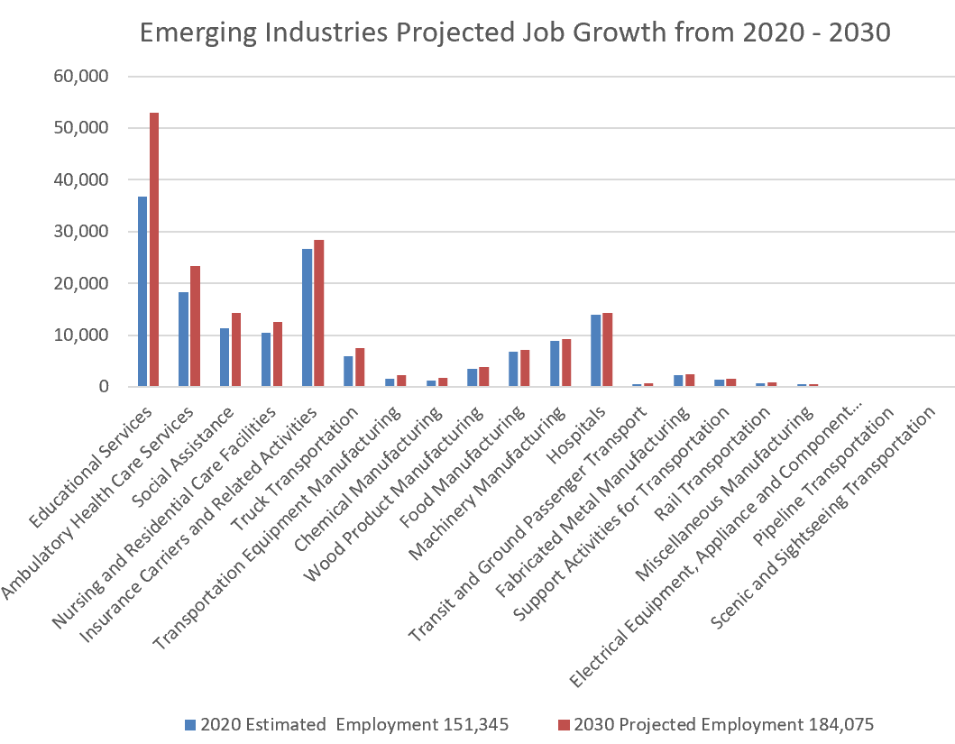

Industry Growth by % 2020-2030 (Descending Order – minimum 5,000 projected employment) | NAICS | 2020 Estimated Employment | 2030 Projected Employment | Total Growth
Total All Industries (Non ag) | 000 | 458,065 | 526,165 | 14.9%
Accommodation | 721 | 3,800 | 6,065 | 59.6%
Amusement, Gambling, and Recreation Industries | 713 | 4,475 | 6,570 | 46.8%
Educational Services | 611 | 36,690 | 53,010 | 44.5%
Management of Companies and Enterprises | 551 | 9,760 | 13,045 | 33.7%
Administrative and Support Services | 561 | 20,500 | 26,265 | 28.1%
Ambulatory Health Care Services | 621 | 18,365 | 23,290 | 26.8%
Social Assistance | 624 | 11,310 | 14,300 | 26.4%
Truck Transportation | 484 | 6,020 | 7,465 | 24.0%
Nursing and Residential Care Facilities | 623 | 10,455 | 12,600 | 20.5%
Specialty Trade Contractors | 238 | 17,035 | 20,000 | 17.4%
Professional, Scientific, and Technical Services | 541 | 24,140 | 27,630 | 14.5%
Food Services and Drinking Places | 722 | 25,985 | 29,165 | 12.2%
Motor Vehicle and Parts Dealers | 441 | 6,165 | 6,760 | 9.7%
General Merchandise Stores | 452 | 8,440 | 9,170 | 8.6%
Insurance Carriers and Related Activities | 524 | 26,675 | 28,455 | 6.7%
Credit Intermediation and Related Activities | 522 | 23,575 | 25,080 | 6.4%
Local Government, Excluding Education and Hospitals | 930 | 11,410 | 12,060 | 5.7%
Self Employed and Unpaid Family Workers | 671 | 33,435 | 35,165 | 5.2%
Food and Beverage Stores | 445 | 11,445 | 12,035 | 5.2%
Food Manufacturing | 311 | 6,850 | 7,160 | 4.5%
Machinery Manufacturing | 333 | 8,900 | 9,200 | 3.4%
Merchant Wholesalers, Durable Goods | 423 | 10,375 | 10,715 | 3.3%
State Government, Excluding Education and Hospitals | 920 | 9,310 | 9,560 | 2.7%
Hospitals | 622 | 13,925 | 14,225 | 2.2%
Merchant Wholesalers, Nondurable Goods | 424 | 8,110 | 8,200 | 1.1%
Source: Labor Market and Economic Research Bureau, Iowa Workforce Development

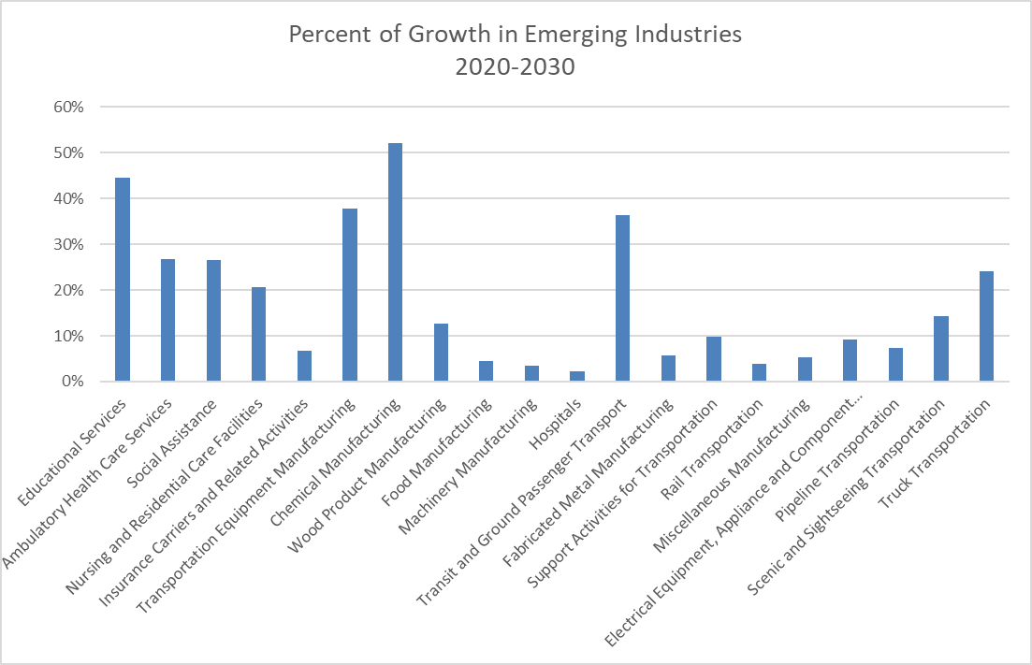
We are spotlighting the emerging and in-demand industry sectors in the Central Iowa workforce area below after a review of the decile rank and growth projections, as well as performing some consolidation of industries. These industry sectors listed below are forecasted for high growth from 2020-2030 in both % of growth and total job need growth. 35% of total jobs in 2030 are forecasted to be in these industries. Each industry title below has a hyperlink to the 2022 Iowa Industry Profile created by Iowa Workforce Development.

    - Educational Services
    - Finance and Insurance
    - Health Care and Social Assistance
    - Manufacturing
    - Construction and Skilled Trades
    - Transportation and Warehousing

Additionally, industries of Childcare (included in social assistance), Retail, and Accomodation and Food Service are important to the Central Iowa economy and have significant workforce needs. However, a limitation of many of the occupations within the industry sectors is that they do not pay a livable wage or lead to a sustainable career, therefore negatively impacting the talent pipeline to support the business model. Occupations such as waitress, clerk, and childcare provider do make available entry level jobs that develop work experience and soft skill for workers. Employees may derive other benefits such as positive socialization and sense of service to society. Part-time workforce development strategies may also contribute to the workforce needs of these occupations. To fully meet the workforce needs of these sectors a systems approach including a variety of stakeholders involvement is needed; including private business, government, economic development, and non-profit.

Occupation: Employment & Wages
Occupational projections, also known as forecasts, provide detailed information on the estimated activity for each occupation in areas of employment, growth rate, openings, wages, career preparation and skill requirements. Data is available for the State of Iowa and local areas HERE. (Iowa Workforce Development – Industry Profiles) The outlook specific to the Central Iowa Local Workforce Area can be found HERE

IowaWORKS Career Planners are available for all Iowans to help them interpret labor market information and assist in determining a career pathway that is appropriate for the individual. That match should consider a candidate’s interests, experiences, and competencies, as well as employer’s needs and availability of good jobs in the area.

While some occupations may often correlate to specific industries and sectors, occupations often cross industries and sectors. For example, business and financial operations occupations could be in education, retail, or health care, etc. Our local board prioritizes career pathways and workforce system strategic coordination that supports both the industry sector priorities in the area and occupational needs. One way of doing so is recruiting board members to the board’s business positions that provide employment opportunities in those sectors and occupations. Resources used on outreach, career pathway development, and individual training accounts will also follow this strategic alignment.
Top Occupations | Estimated Employment | Mean Wage | Entry Wage | Experienced Wage
Retail Salespersons | 11,370 | $15.21 | $10.54 | $17.54
Cashiers | 11,210 | $12.44 | $9.97 | $13.68
Customer Service Representatives | 10,620 | $20.77 | $14.64 | $23.83
Fast Food and Counter Workers | 9,980 | $11.92 | $9.55 | $13.11
General and Operations Managers | 9,710 | $47.71 | $22.69 | $60.22
Registered Nurses | 8,550 | $31.88 | $26.35 | $34.64
Heavy and Tractor-Trailer Truck Drivers | 8,020 | $24.80 | $18.15 | $28.13
Office Clerks, General | 7,920 | $18.74 | $13.07 | $21.58
Laborers and Freight, Stock, and Material Movers, Hand | 6,590 | $17.99 | $13.11 | $20.43
Stockers and Order Fillers | 6,460 | $16.69 | $12.59 | $18.74
Bookkeeping, Accounting, and Auditing Clerks | 6,330 | $22.60 | $15.92 | $25.94
Home Health and Personal Care Aides | 6,260 | $14.18 | $11.59 | $15.47
Janitors and Cleaners, Except Maids and Housekeeping Cleaners | 6,170 | $14.83 | $11.02 | $16.73
Teaching Assistants, Except Postsecondary | 5,600 | $27,909 | $21,574 | $31,076
Software Developers | 5,030 | $47.78 | $34.17 | $54.59
Nursing Assistants | 4,830 | $15.91 | $14.04 | $16.85
Sales Representatives, Wholesale and Manufacturing, Except Technical and Scientific Products | 4,720 | $34.97 | $18.72 | $43.09
Waiters and Waitresses | 4,680 | $12.26 | $8.79 | $13.99
Accountants and Auditors | 4,520 | $36.55 | $24.84 | $42.40
Financial Managers | 4,180 | $66.43 | $39.42 | $79.94
Elementary School Teachers, Except Special Education | 4,000 | $56,841 | $39,004 | $65,760
Source: Labor Market and Economic Research Bureau, Iowa Workforce Development
Occupations paying $16.00/hr + are bolded. Wage according to Common Good Iowa for a single adult to earn a self-sufficient wage.

Top 10 Occupations – By Occupational Group | Estimated Employment | Mean Wage | Entry Wage | Experienced Wage
Office and Administrative Support Occupations | 57,650 | $21.39 | $14.58 | $24.80
Sales and Related Occupations | 42,590 | $21.26 | $10.96 | $26.41
Business and Financial Operations Occupations | 36,010 | $36.47 | $22.91 | $43.24
Transportation and Material Moving Occupations | 34,680 | $19.99 | $12.84 | $23.56
Food Preparation and Serving Related Occupations | 32,830 | $13.19 | $9.60 | $14.99
Management Occupations | 31,040 | $54.20 | $26.87 | $67.86
Educational Instruction and Library Occupations | 26,680 | $25.24 | $12.72 | $31.50
Production Occupations | 25,420 | $20.33 | $13.86 | $23.57
Healthcare Practitioners and Technical Occupations | 22,940 | $39.96 | $20.19 | $49.85
Construction and Extraction Occupations | 20,610 | $25.86 | $17.33 | $30.12
Source: Labor Market and Economic Research Bureau, Iowa Workforce Development
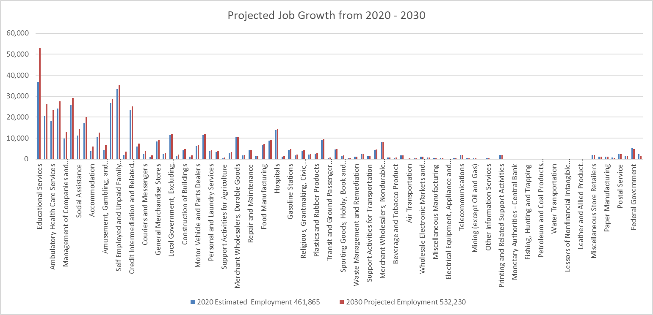

- Workforce Analysis: Include a current analysis of:
  - The knowledge and skills needed to meet the employment needs of employers in the local area, including employment needs in in-demand industry sectors and occupations.
  - An analysis of the local workforce, including current labor force employment and unemployment data, information on labor market trends, and education and skill levels of the workforce, including individuals with barriers to employment.

Iowa Workforce Development (IWD) conducted the seventh Workforce Needs Assessment Survey during the fall of 2022 through the spring of 2023. This survey collects information from employers across the state regarding their vacancies, workforce challenges, difficulties in hiring, perceptions of applicants, advertising outlets for job openings, and upcoming retirements—among other questions. In the Central Iowa LWDA, 9,903 locations were contacted. By the end of the survey period (March 2023), IWD received 2,430 responses from employers in the Central Iowa LWDA, for a response rate of 24.5% (by locations contacted).

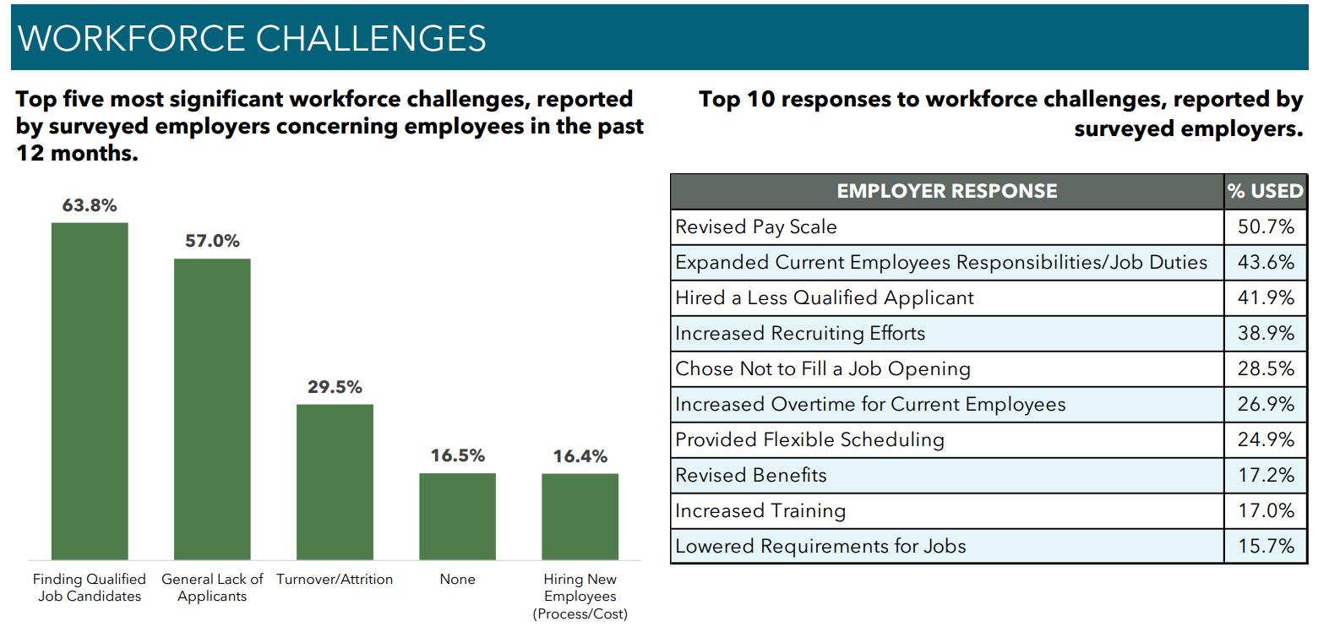
The findings show the main issue facing business is a general struggle with the lack of qualified candidates and applicants. Businesses tended to respond to that challenge by trying to compete for employees by increasing wages, increasing current employee job duties, or lowering position requirements for new hires. Those strategies alone only provide short term solutions but aren’t sustainable for a business's success in the long run. The study shows that the importance of developing a positive workplace culture is one of the most effective retention strategies, including the upskilling of current workers.
Perception of Applicants:
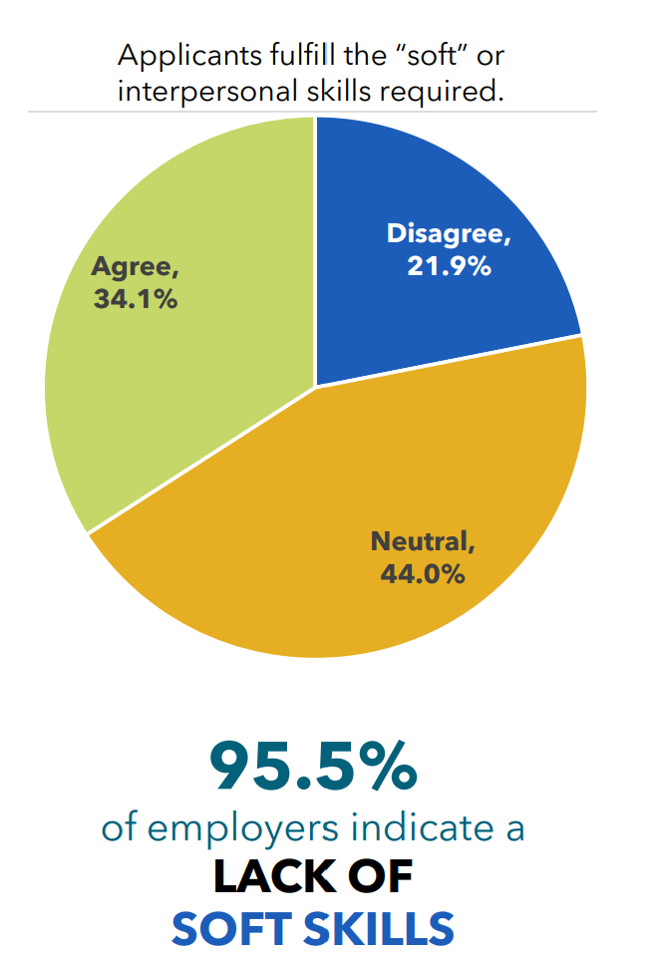 | Top Lacking Job Skills:  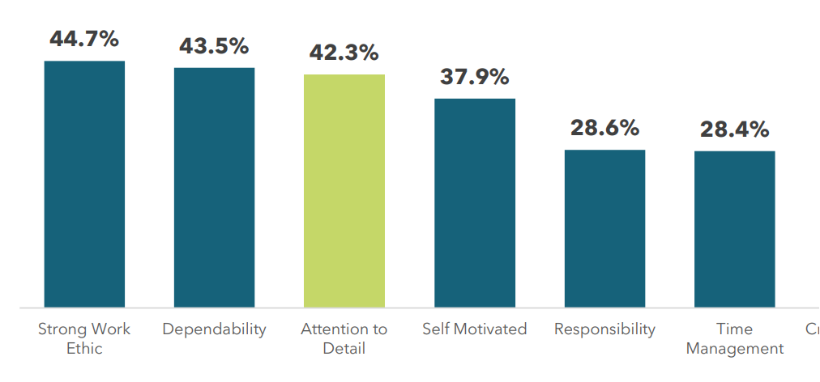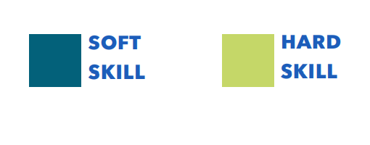
Source: Iowa Workforce Development Needs Assessment (2023) https://workforce.iowa.gov/media/1299/download?inline=

Employers reported that the lack of soft skills significantly outweighed the lack of basic or hard skills in applicants. Soft skills are most often considered associated with an individual's habits, personality, and character. Examples include dependability, honesty, self-motivation, time management, teamwork, etc.

Labor Force: Educational Attainment
- A high percentage (13%) of the construction and manufacturing workforce do not have a high school diploma.
- Finance and Insurance 41%, Education Services 39%, and Professional, Scientific, and Technical Services 38%, have the highest % of bachelor's or advanced degrees employees.

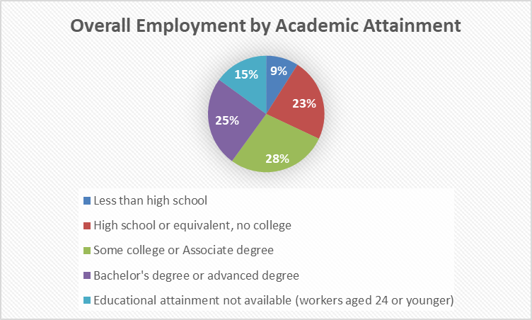

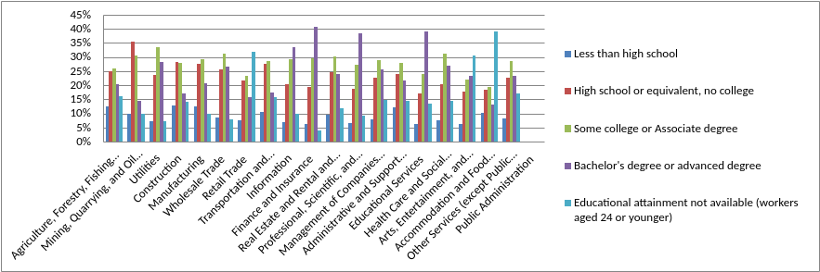

Labor Force: Age
- An additional 22% of our current workforce (currently age 55+) will be retirement eligible in 10 years.
- Accommodation and Food Services, Art, Entertainment and Recreation, and Retail Trade, have a high rate of 14–24-year-olds.
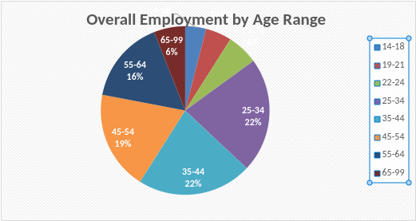
Industry by age | 14-18 | 19-21 | 22-24 | 25-34 | 35-44 | 45-54 | 55-64 | 65-99
Agriculture, Forestry, Fishing and Hunting | 6% | 5% | 6% | 18% | 19% | 17% | 17% | 12%
Mining, Quarrying, and Oil and Gas Extraction |  | 4% | 6% | 25% | 19% | 18% | 23% | 5%
Utilities |  | 2% | 5% | 25% | 23% | 21% | 21% | 3%
Construction | 1% | 6% | 7% | 25% | 24% | 19% | 13% | 4%
Manufacturing | 1% | 4% | 5% | 21% | 23% | 22% | 19% | 5%
Wholesale Trade | 1% | 3% | 4% | 20% | 24% | 23% | 20% | 6%
Retail Trade | 12% | 12% | 8% | 18% | 15% | 14% | 14% | 8%
Transportation and Warehousing | 2% | 6% | 7% | 22% | 19% | 19% | 17% | 7%
Information | 3% | 3% | 4% | 22% | 25% | 21% | 18% | 4%
Finance and Insurance | 0% | 1% | 3% | 22% | 29% | 25% | 17% | 3%
Real Estate and Rental and Leasing | 2% | 4% | 7% | 23% | 22% | 19% | 17% | 8%
Professional, Scientific, and Technical Services | 1% | 2% | 6% | 26% | 25% | 20% | 15% | 6%
Management of Companies and Enterprises | 5% | 5% | 5% | 21% | 22% | 20% | 17% | 5%
Administrative and Support and Waste Management and Remediation Services | 1% | 5% | 8% | 25% | 21% | 18% | 15% | 7%
Educational Services | 4% | 4% | 6% | 19% | 23% | 20% | 17% | 8%
Health Care and Social Assistance | 2% | 5% | 7% | 24% | 23% | 18% | 15% | 6%
Arts, Entertainment, and Recreation | 13% | 10% | 8% | 19% | 16% | 13% | 11% | 9%
Accommodation and Food Services | 17% | 12% | 9% | 20% | 16% | 11% | 9% | 5%
Other Services (except Public Administration) | 4% | 6% | 7% | 22% | 20% | 18% | 15% | 8%
Total | 4% | 5% | 6% | 22% | 22% | 19% | 16% | 6%

Labor Force: Race
- Minorities (non-white) are highly represented in the in-demand and emerging industries of transportation and warehousing (17%), as well as manufacturing (17%).
- Minorities (non-white) are underrepresented in the in-demand and emerging industries of construction (6%) and educational services (8%).

 | White Alone | Black Alone | Asian Alone | Two or More Race Groups | Minority Combined
Agriculture, Forestry, Fishing and Hunting | 95% | 2% | 2% | 1% | 5%
Mining, Quarrying, and Oil and Gas Extraction | 98% | 1% |  |  | 1%
Utilities | 96% | 2% | 1% | 1% | 4%
Construction | 94% | 3% | 1% | 2% | 6%
Manufacturing | 83% | 7% | 9% | 2% | 17%
Wholesale Trade | 93% | 3% | 2% | 1% | 7%
Retail Trade | 89% | 5% | 3% | 2% | 11%
Transportation and Warehousing | 83% | 11% | 3% | 2% | 17%
Information | 91% | 4% | 3% | 2% | 9%
Finance and Insurance | 92% | 3% | 4% | 1% | 8%
Real Estate and Rental and Leasing | 92% | 4% | 2% | 2% | 8%
Professional, Scientific, and Technical Services | 91% | 2% | 6% | 1% | 9%
Management of Companies and Enterprises | 92% | 4% | 3% | 2% | 8%
Administrative and Support and Waste Management and Remediation Services | 82% | 12% | 3% | 2% | 18%
Educational Services | 93% | 3% | 3% | 2% | 8%
Health Care and Social Assistance | 88% | 7% | 3% | 2% | 12%
Arts, Entertainment, and Recreation | 92% | 4% | 2% | 2% | 8%
Accommodation and Food Services | 83% | 7% | 5% | 3% | 17%
Other Services (except Public Administration) | 91% | 3% | 3% | 2% | 9%
OVERALL | 90% | 4% | 3% | 2% | 10%

Labor Force: Sex
- Men make up 58% of the current workforce.
- Men are underrepresented in the in-demand and emerging industries of educational services (34%) and health care/social assistance (19%) compared to their overall representation of 58% of the workforce.
- Women are underrepresented in the in-demand and emerging industries of construction (14%) and manufacturing (28%). They also represent just 27% of the transportation workforce.

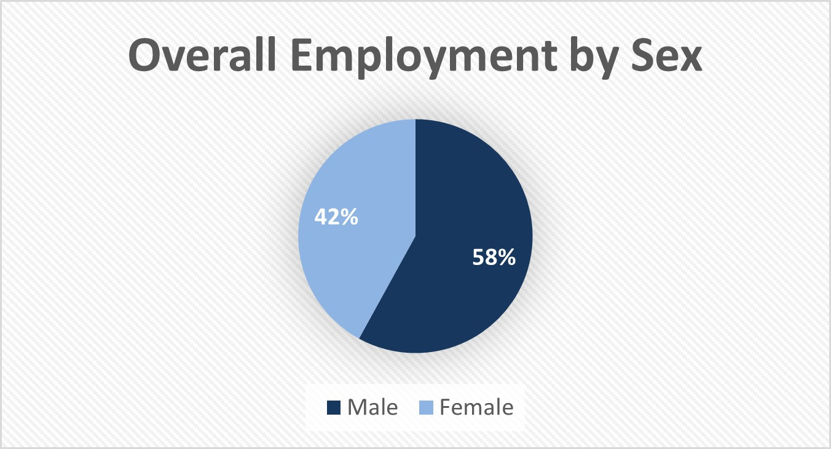

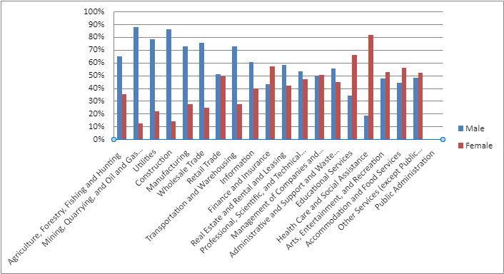Iowa LMI

Unemployment in Central Iowa largely mirrors the statewide trendline, while slightly outperforming the rest of the state. Without a major event impacting our economy, low unemployment is likely to continue in the future due to slowing population replenish rates and the retirement of baby boomers. Changes to policy related to the shortening of duration of time temporary layoffs can receive unemployment benefits may also slightly lower the unemployment rate compared to prior time periods.

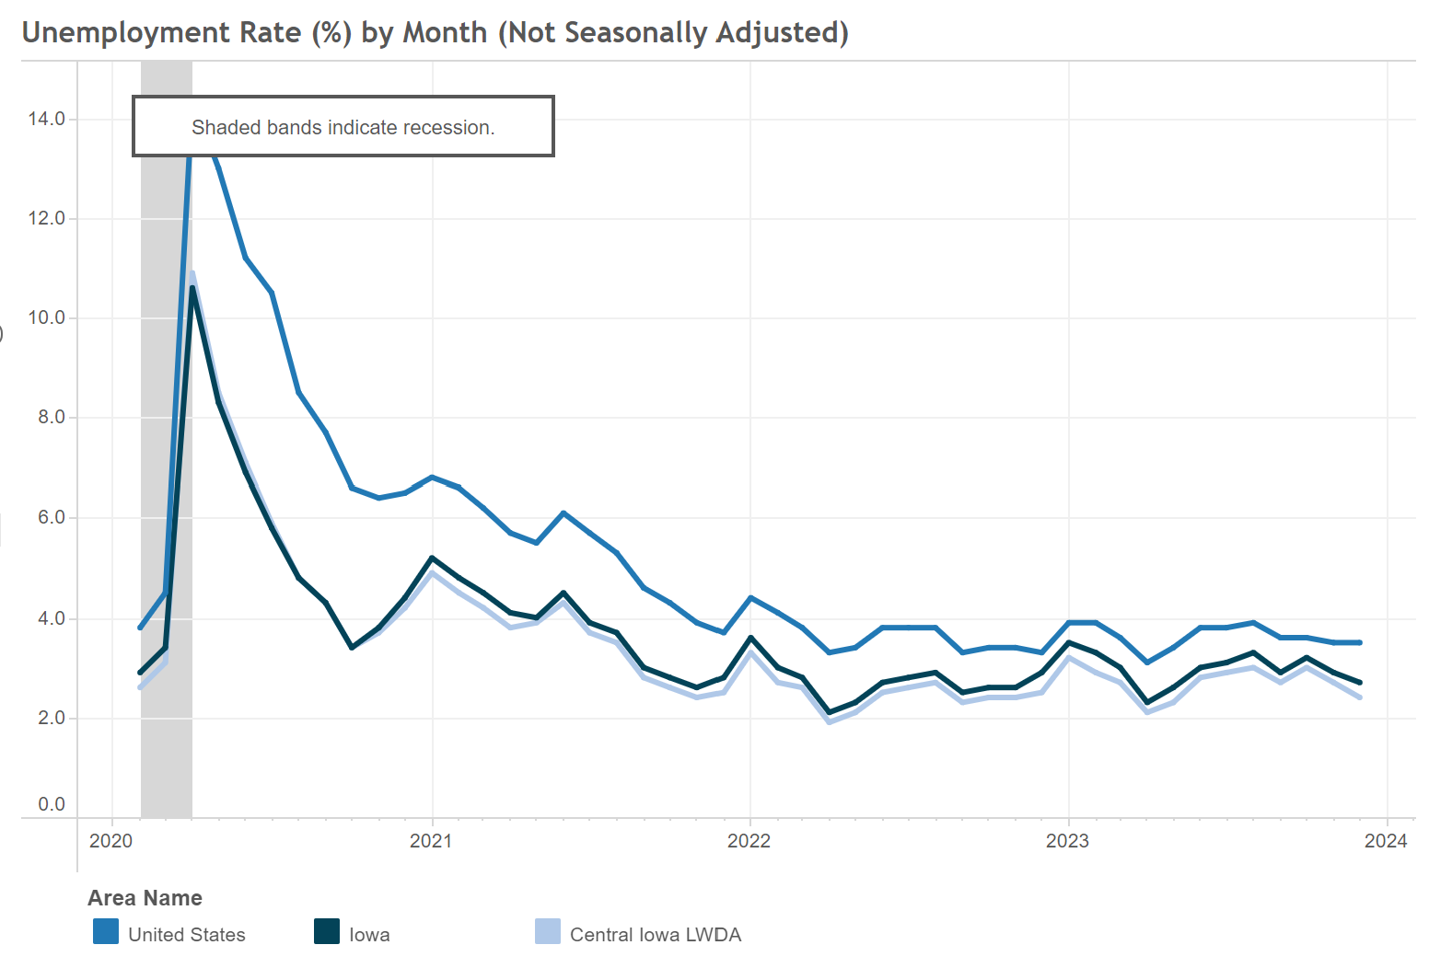

December 2023 – Unemployment Rate
County | Labor Force | Employed | Unemployment | Unemployment Rate
Boone | 14,620 | 14,320 | 300 | 2.1%
Dallas | 53,800 | 52,700 | 1,100 | 2.0%
Jasper | 17,930 | 17,460 | 470 | 2.6%
Madison | 8,700 | 8,500 | 200 | 2.8%
Marion | 19,470 | 19,110 | 360 | 1.8%
Polk | 275,300 | 268,000 | 7,300 | 2.6%
Story | 58,600 | 57,500 | 1,100 | 1.9%
Warren | 29,200 | 28,500 | 700 | 2.4%
Iowa Workforce Development

The Laborshed Information Study iowalmi.gov/laborshed provides statistics on population 18+, employed, unemployed, homemakers, retirees. The study found that in Central Iowa, there are 904,486 people between the ages of 18-64. Of those, 747,976 (82.6%) are participating in the labor force. Encouraging those voluntarily not in the labor force to enter through part time work or volunteerism, could help meet labor shortage needs. That could additionally include those above 64 or under 18 not looking for full-time employment.

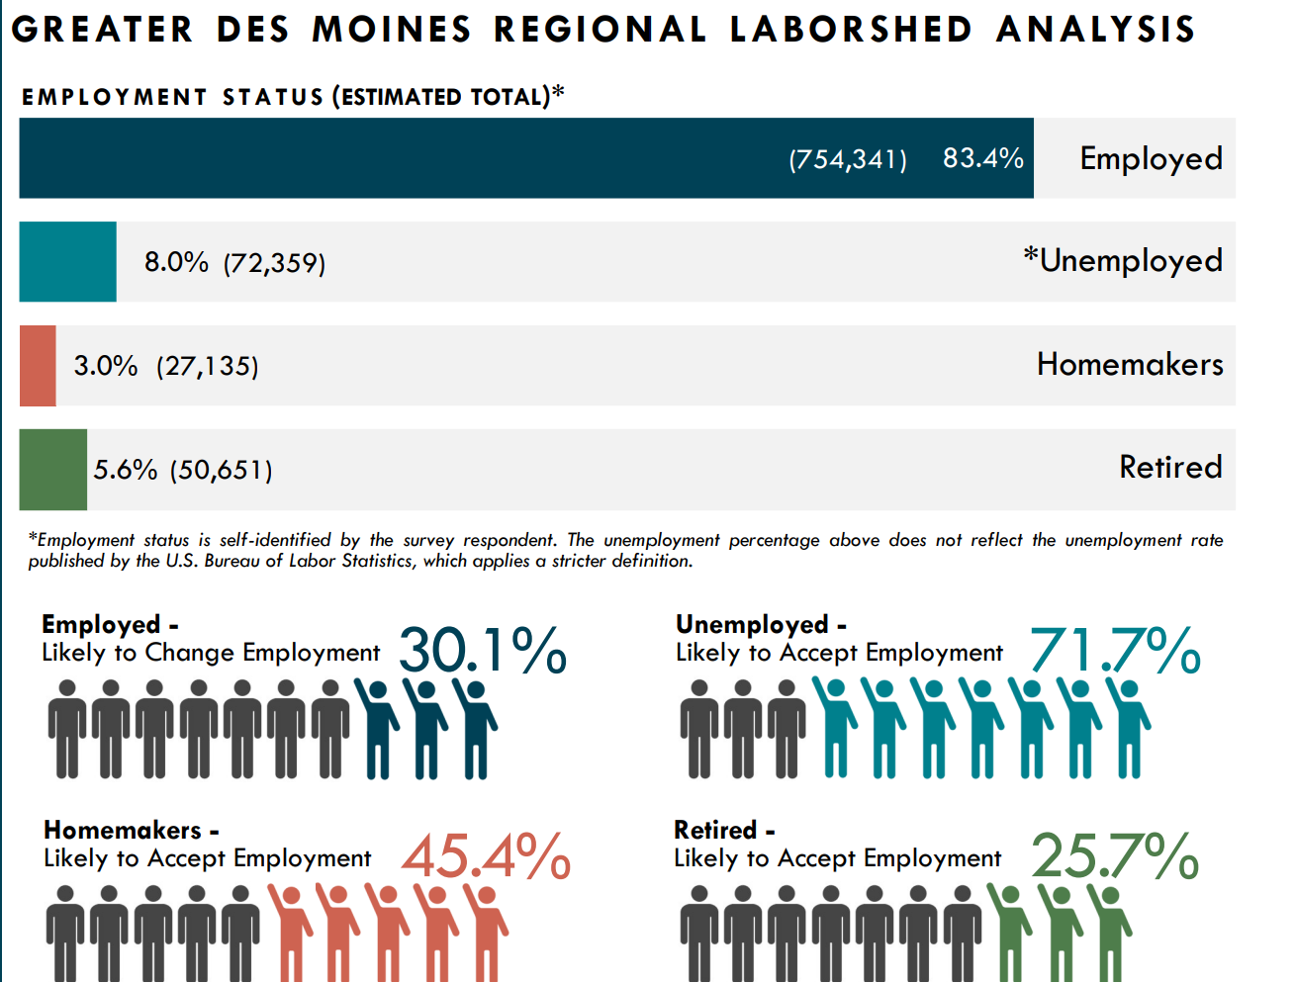

County Data (*U.S. Census 2017-2021) | Iowa | Central Iowa | Boone | Dallas | Jasper | Madison | Marion | Story | Warren | Polk
Population Estimates (July 2020) | 3,200,519 | 878,330 | 26,609 | 108,016 | 37,938 | 17,036 | 33,642 | 99,673 | 54,327 | 501,089
Number of households* | 1,275,893 | 335,402 | 10,720 | 37,970 | 14,370 | 6,377 | 13,241 | 37,944 | 19,517 | 195,263
Median household income in past 12 months (in 2020-2021 dollars)* | $65,429 | $74,322 | $70,984 | $93,492 | $63,189 | $79,306 | $66,822 | $62,578 | $85,189 | $73,015
Per capita income in past 12 months (in 2020-2021 dollars)* | $34,817 | $37,417 | $36,145 | $47,488 | $32,358 | $39,024 | $34,545 | $33,211 | $38,087 | $38,475
Total employment (2021) | 1,352,146 | 386,847 | 6,842 | 40,688 | 8,364 | 2,664 | 17,071 | 31,361 | 8,653 | 271,204
High school graduate or higher; % of persons age 25+* | 92.80% | 94.98% | 94.10% | 95.90% | 94.10% | 96.50% | 94.00% | 96.90% | 95.80% | 92.50%
Bachelor's degree or higher, % of persons age 25+* | 29.70% | 238.95% | 25.60% | 50.40% | 19.10% | 24.80% | 30.90% | 51.10% | 32.30% | 38.00%
Households with a computer* | 91.70% | 93.50% | 92.40% | 95.90% | 90.30% | 92.30% | 91.20% | 95.80% | 95.10% | 94.70%
Households with a broadband internet subscription* | 84.90% | 85.20% | 83.90% | 90.30% | 84.40% | 85.20% | 83.70% | 77.10% | 88.50% | 88.20%
Persons with a disability, under age 65* | 8.10% | 7.40% | 8.40% | 4.50% | 8.50% | 6.40% | 9.40% | 6.10% | 7.60% | 8.00%
Persons without health insurance, under age 65* | 5.80% | 4.90% | 5.00% | 4.10% | 4.40% | 5.90% | 4.10% | 5.60% | 4.20% | 5.60%
Race: White alone* | 89.80% | 92.40% | 96.20% | 88.80% | 95.00% | 96.70% | 95.90% | 86.70% | 96.00% | 83.80%
Persons in poverty | 11.10% | 9.00% | 7.80% | 5.30% | 9.30% | 7.40% | 8.60% | 17.90% | 5.40% | 10.10%

- Workforce Development, Education and Training Analysis: Include an analysis of:
  - The strengths and weaknesses of workforce development activities.
  - Capacity to provide workforce development activities to address the education and skill needs of the workforce, including individuals with barriers to employment.
  - The employment needs of employers.

STRENGTHS of Workforce Development Activities in Central Iowa
- Training Providers (Strength in Variety, Quantity, and Quality)
  - Strong Community College System – Des Moines Area Community College (DMACC) has world class facilities, programs, and a strong brand to meet many of the needs for post-secondary education in Central Iowa. DMACC campuses are spread throughout the area and have a variety of environments and programs to provide training in many occupations. Campus locations are:
    - Ankeny 2006 South Ankeny Boulevard Ankeny, IA 50023 (Polk County)
    - Boone 1125 Hancock Drive Boone, IA 50036 (Story County)
    - Carroll 906 North Grant Road Carroll, IA 51401-2525 (outside CIWDA)
    - Newton 600 N. 2nd Ave. West Newton, IA 50208 (Jasper County)
    - Urban 1100 7th Street Des Moines, IA 50314 (Polk County)
    - West 5959 Grand Avenue West Des Moines, Iowa 50266 (Polk County)
    - Other Specialty Locations
  - Universities – Many great colleges and universities are available in Central Iowa. They include state and private universities and provide a variety of specializations and course work for those pursuing a bachelor's or graduate degree. There are also many remote and satellite options available.
    - Iowa State (Story County)
    - Drake (Polk County)
    - Grandview (Polk County)
    - Des Moines University (Polk County)
    - Mercy College of Health Sciences (Polk County)
    - Simpson College (Warren County)
    - Central College (Marion County)
    - Various Satellite Campuses; including but not limited to Viterbo and the University of Iowa, University of Northern Iowa, William Penn University, and Upper Iowa.
  - Work-Based Learning
    - K-12 Schools – There are many outstanding Work-Based Learning programs throughout Central Iowa, many of which are housed within K–12 school districts, and most often operated by the school district. Programs partner with training institutions such as DMACC and Iowa Skilled Trades, and private employers provide various student experiences.
    - A map of public schools follows where there are Work-Based Learning (WBL) opportunities can be found at (Source: http://iowastudentoutcomes.com/WBL_outcomes)
      - Boone County: 3 school districts, with 3 high schools;
      - Dallas County: 7 public school districts, 1 non-public high school, with 8 high schools;
      - Jasper County: 5 public districts, with 7 high schools;
      - Madison County: 3 public school districts with 3 high schools;
      - Marion County: 5 public high school districts and 2 non-public schools with 7 high schools;
      - Polk County: 9 public high school districts, and 4 non-public high schools with 21 high schools;
      - Story County: 7 public school districts with 7 high schools;
      - Warren County: 5 public school districts with 5 high schools.
    - Apprenticeships – There are state resources available to support work–based learning initiatives in Central Iowa, as well. A well-known resource is the Earn and Learn website. (earnandlearniowa.gov)
    - Private and Non-Profit Work-Based Learning Providers – Programs like Iowa Jobs after Graduation (IJAG) have a Central Iowa and statewide presence. Avenue Scholars, a private provider, is in partnership with the Des Moines Public School System, and provides innovative, long-term career and training resources to work–based learning for Iowa students. WIOA Title I Youth provides individual support for those 14-24 most vulnerable, most typically targeted those disengaged from school. That makes programs like IJAG and Avenue Scholars great referral partners for those students.
  - Iowa Skill Trades – Local Union Training Facilities – Iowa Skilled Trades offers many training schools in in–demand jobs across Central Iowa. They partner with businesses and schools to train apprentices and provide them with journeyman credentials. https://iowaskilledtrades.com/

- Program Providers
  - Central Iowa has several programs and partners that serve individuals with barriers to employment. Below is not an exhaustive list, but are a few examples that include initiatives for:
    - Returning Citizens Initiative - Operations Manager – Shelley Seitz, Iowa Workforce Development
    - Newcomers and Refugees. Bureau of Refugee Services, Program Manager, Edgar Ramirez. DMACC/Evelyn K Davis Center, Refugee Alliance of Central Iowa (RACI), Lutheran Services, Genesis Youth Foundation, Oakridge Neighborhood, and other organizations also support newcomers and refugee employment.
    - Individuals with Disabilities – Title IV Iowa Vocational Rehabilitation Services and Department for the Blind, as well as organizations like ChildServe, Easter Seals, On with Life, and Goodwill.
    - All of our IowaWORKS Memorandum of Understanding (MOU) Required Partners provide services to individuals with barriers to employment.

- Economic Development Partners – We have strong relationships with Economic Development organizations in Central Iowa and look forward to growing relationships with them and adding new relationships. Some current strategic partners include:
  - Greater Des Moines Partnership
  - United Way of Central Iowa
  - Story County Chamber of Commerce
  - Employment Council of Iowa (ECI)
  - Greater Des Moines Foundation
  - Marion County Economic Development
  - Pella Area Economic Development

Opportunities to Improve Workforce Development Activities
- Technological Infrastructure
  - Lacking Technological Resources at IowaWORKS - IowaWORKS lacks state-of-the-art software for internal client management and partner integration. We will advocate for enhancing the technology available to our center, to improve partner communication and referral coordination.
  - Quality of Community Facing Website-The IowaWORKS website does not provide the user experience expected by our consumers to truly define our position as the leading service provider in Iowa for workforce solutions. We will advocate for updating to a modern community facing website for individuals. That could also include a stronger virtual platform for client service provision.
  - Connections between business and training providers; including Work Based learning programs. - Common feedback is that work-based learning programs need business participation to advance their programs and student learning but struggle to create and develop those relationships. However, employers haven’t found the strategic capacity to connect, develop and provide work-based learning opportunities. Businesses also report fatigue in having many different points of contact for work-based learning programs leading to confusion or competition among programs rather than coordination, streamline, and efficiency.

Capacity to provide workforce development activities to address the education and skill needs of the workforce, including individuals with barriers to employment.
- Lack of Population Growth and its impact on Workforce capacity – Baby Boomers are leaving the workforce. The population replenish rate and state immigration rate are not producing the labor force to meet demand for workers.
- Concern for capacity to serve Individuals with Disabilities - We are concerned about the system capacity for serving Iowans with disabilities, specifically that of Iowa Vocational Rehabilitation Services. The state agency has not been able to meet the demand for services, displayed by long waiting lists, excessive caseloads, and extensive staff turnover. These trends are not specific to just Central Iowa alone, but also national trends. We will continue to advocate, coordinate and explore capacity building for all partners serving those with disabilities.
- Concern for capacity to serve English Language Learners – We are concerned about our ability to meet the demand for English Language Acquisition. Our Title II ELL classes have waitlists, and more providers of ELL is necessary to meet the emerging needs of newcomers and refugees in Iowa.

- Vision - Include a description of:
  - The LWDB’s strategic vision to support the economic growth and economic self- sufficiency of the local area, including:
    - Goals for preparing an educated and skilled workforce, including youth and individuals with barriers to employment.
    - Goals relating to performance accountability measures based on the performance indicators.
  - The LWDB’s strategic vision to align local resources, required partners, and entities that
carry out core programs to achieve strategic vision and goals.

- Strategies – Taking into account the analyses described in sections 1-3 above:
  - Describe the strategy to work with the entities that carry out the core programs and required partners to align resources available in the local area to achieve the strategic vision and goals described in section 4 above.

CIWDA Vision:
All Central Iowans are engaged and thriving in our workforce.
CIWDB Values:

Informed, Innovative, Accountable, Flexible, Responsive
Central Iowa Goals and Strategies:
- Goal: Strengthen the connectedness of the workforce system across Central Iowa.
  - Engage non-WIOA required community partners across Central Iowa in the workforce system.
  - Launch, develop, and sustain robust sector partnerships in collaboration with community stakeholders.
  - Coordinate with local economic development partners to avoid duplication of services and build a pipeline for business board local board members.
  - Engage business leaders to overcome issues in training, upskilling and retaining workforce in their sectors.
  - Coordinate and facilitate access to supportive services and quality organizations that provide such services.
- Goal: Strategic Communication across the Central Iowa workforce area.
  - Create and execute external communication and brand strategies that create a unified presentation for the Central Iowa Workforce Area, IowaWORKS, and its program partners.
  - Improve internal communication to ensure all IowaWORKS partner programs are aware of the key activities of all WIOA required partners and have adequate resources to coordinate client centered referrals and integrated program efforts.
  - Ensure Career Pathways are accessible to all Iowans and are focused on overcoming barriers for underrepresented populations.
  - Promote best practices and bright spots throughout Central Iowa to support meeting workforce needs, provide technical assistance and innovative solutions.
- Goal: Target at risk youth and young adults.
  - Create strategic links to school-based programs working with youth and young adults ages 16-24 who need support after exiting their school environment.
  - Strategic partnerships with alternative and rural schools in the secondary school system to increase access to work-based learning participation.
  - Expand and support linkages from Title I Youth and Youth Adult services to other youth serving required partner programs such as Job Corp, Vocational Rehab, and HiSet participants.

SECTION 3 – IowaWORKS SYSTEM COORDINATION
Questions in this section are designed to address collaboration and coordination across workforce system partners to ensure the LWDB is administering an effective and efficient local workforce system.
- The workforce development system in the local area, including the identification of:
- The programs included in the system.
- Describe the steps the LWDB will take to locally implement and support the state strategies identified in the State Plan and work with the entities carrying out core programs and other workforce development programs, including programs of study authorized under the Carl D. Perkins Career and Technical Education Act of 2006, to support service alignment.

Required Partner Program | Local Provider
Title I Adult and Dislocated Worker Services  Title I Youth Services | Children and Families of Iowa Children and Families of Iowa
Tile II Adult Education and Literacy | DMACC
Title III Wegner Peyser Employment Services | Iowa Workforce Development
Title IV Vocation Rehabilitation Services | Iowa Vocational Rehab
Title IV | Iowa Dept for the Blind
Senior Community Services Employment Program (SCSEP) | AARP Foundation, ABLE Network
National Farmworker Jobs Program (NFJG) | Proteus
Native American Programs | American Indian Council
Temporary Assistance for Needy Families (TANF) - PROMISE Jobs | Iowa Workforce Development
Unemployment Compensation | Iowa Workforce Development
Jobs for Veterans State Grant (JVSG) | Iowa Workforce Development
Reentry Employment Opportunities (REO) | Iowa Workforce Development
Reemployment Services and Eligibility Assessment (RESEA) | Iowa Workforce Development

STATE OF IOWA WORKFORCE VISION AND STRATEGIES
Guided by Governor Reynolds’s vision to build an aligned and integrated workforce system, Iowa’s WIOA Unified State Plan establishes two goals and corresponding strategies for the state workforce system.

Iowa’s Vision:
An aligned, flexible, and streamlined workforce delivery system that meets the needs of employers and all Iowans for a skilled and diverse workforce.

Goals and Strategies:
Goal I: Increase the engagement and awareness of Iowa’s current, potential, and future workforce to the continuum of high-quality education, training, and career opportunities in Iowa.
State Strategy 1.1: Align and implement an accessible, integrated service delivery model incorporating all workforce system partners.
State Strategy 1.2: Ensure all Iowa students have opportunities for meaningful work-based learning experiences.
State Strategy 1.3: Target services to underserved populations, including individuals with disabilities, minorities, returning citizens, women, rural Iowans, new citizens, veterans, etc.

Goal II: Increase employer engagement and awareness of the IowaWORKS system as the premier provider of business services for a skilled and diverse workforce.
State Strategy 2.1: Support local workforce boards in the development and enhancement of sector partnerships.
State Strategy 2.2: Create and implement a unified and collaborative business engagement model.
State Strategy 2.3: Increase the awareness and engagement by employers in work-based learning opportunities.

The Local Workforce Area will take the following steps to support the State of Iowa Goals.

State Goal 1: Increase the engagement and awareness of Iowa’s current, potential, and future workforce to the continuum of high-quality education, training, and career opportunities in Iowa.
The local board takes its role seriously in the One-Stop Certification of the local center, focusing on effectiveness, accessibility, and continuous improvement. However, we also realize that it is important to align services outside the walls of the IowaWORKS center and involve non-WIOA Memorandum of Understanding (MOU) partners in our work. This commitment to including community-based partners will support state strategy 1.1 by having the board connect these entities.

We will support the efforts of all students with work-based learning experiences (strategy 2.2) in many ways. We will develop relationships with the outstanding school-based providers across our K-12 schools, especially in our larger districts. We will be an asset to them to help support their work through technical assistance and identification of business partners. We will also ensure they know we are there for case management services for their students who have the greatest needs for referral and enrollment. We will intentionally form relationships with smaller school districts that lack work-based learning resources and look to fill the gap. With the request for raising the limit on in-school funding we can more liberally work with some of our students in alternative school formats across Central Iowa who are classified as “in-school youth.” We can also focus on serving young adults who have graduated from high school but have yet to find their stride in the workforce, suggesting “earn to learn” formats when appropriate. Referrals from school-based resources will be critical in the identification of youth to serve in our program.

In addition to the strategies mentioned for reaching youth, we are also committed to working with other underrepresented populations, as reference in state strategy 1.3. We will lead innovative approaches to redistribute the work in serving individuals with a disability away from solely on IVRS and explore other Core Partners and community partners that can assist in filling the void. We will form strategic partnerships and continue our exploration of integrated employment and training (IET) tactics with English language learners and newcomers. We will do the same with our department of corrections to support re-entry initiatives.
Goal II: Increase employer engagement and awareness of the IowaWORKS system as the premier provider of business services for a skilled and diverse workforce.
We will embrace sector partnership technical advice to support state strategy 2.1. Our local board is well positioned to be a catalyst in this work, with strong ties to economic development partners that have a mutual interest in success, including the Greater Des Moines Partnership and United Way of Central Iowa. We also have administrative capacity to support the function.

In the IowaWORKS Des Moines office, we have a strong internal infrastructure for business collaboration among partners supporting state strategy 2.2. Board staff are active in working with Business Engagement consultants to strategically manage relationships across the area; not just with business but other government and non-for-profit organizations. The One-Stop Operator convenes monthly meetings for all partner business engagement reps to compare business and contacts and collaborate on activities. Furthermore, there are strong links to DMACC’s business engagement team members.

By combining sector partnerships with collaboration in business services, we can leverage those efforts to also increase engagement by employers in work-based learning opportunities (state strategy 2.3). Even when available programs are not under our direct provision at IowaWORKS, we can serve as navigators to statewide programs and resources to ensure there is no wrong front door for businesses, as well as individuals.

Furthermore, our board is committed to operational excellence, using data to analyze, support and design strategy and measure performance. We will ensure that we “begin with the end in mind” related to WIOA Common Measures and understand that our enrollment, assessment, training suitability, and career pathways should be aligned with attainment of those goals. We are assessing our Title I WIOA activities to establish benchmarks and best practices and communicate the economic impact of activities. We have created a balanced dashboard to measure the local workforce area and board’s success. We review the dashboard in monthly committee meetings and quarterly board meetings. We are also committed to improving technology for service provision.

- The Central Iowa Workforce Development Board will work with the entities carrying out the core programs to:
- Expand access to employment, training, education, and supportive services for eligible individuals, particularly individuals with barriers to employment.
- Facilitate the development of career pathways and co-enrollment, as appropriate, in core programs.
- Improve access to activities leading to a recognized postsecondary credential, including a credential that is an industry-recognized certificate or certification (define), portable, and stackable.

The CIWDB will expand access to employment, training, education, and supportive services for eligible individuals, particularly individuals with barriers to employment in a few ways. We will create strategic linkages to core programs outside of the IowaWORKS comprehensive center in Des Moines. That outreach will be delivered by creating access to IowaWORKS core partner staff in locations throughout our counties, including but not limited to schools, libraries, chambers, non-profit, and community-based organizations. These locations are trusted and familiar to residents and will encourage interaction with their local workforce system.

These community-based outreach locations are based on strategic alignment of service goals and are identified by local board members and chief elected officials for the workforce area. This coordination will encourage co-enrollment of services with not just WIOA core and required partners, but others local stakeholders and initiatives across our service area. Local Board members will identify business and community partners to assist the core partners and facilitate access to those partnerships leveraging their community relationships. That leverage will ensure that IowaWORKS programs are well-received and endorsed locally. Examples of contributions could be to open the doors for work-based learning placements or participant recruitment through community partners' communication assets.

Strategic Communication - A strategic outreach plan will be created for system coordination that identifies system stakeholders and defines accountability for contacts and relationship management. Those accountability partners include local board members, board staff, Wagner-Peyser business engagement team members, and other core partner business representatives. We will tailor and segment communication to groups and will include strategies for Economic Development entities, organizations that serve job candidates with Title I eligible barriers, government officials, and business associations.

In-demand sector and occupational outreach campaigns will be created that will invite job seekers into the workforce. Campaigns will introduce careers in ways that are accessible and inclusive based on language and cultural norms to help candidates of all backgrounds visualize themselves in roles that may not be customary, and make success appear achievable.

The current area board and IowaWORKS electronic communication platforms and assets will be synergized to ensure coordinated communication among platforms and owned media. That may include newsletters, social media pages, websites, and other modes of communication. Each tool will have a defined strategy, frequency, measure, and audience to ensure communication is appropriate and effective.

The CIWDB will facilitate the development of career pathways and co-enrollment, as appropriate, in core programs. The launch of sector partnerships in coordination with other local economic development stakeholders will support this. Sector partnerships for in-demand industries are key to evaluating the performance of the system and directing career pathways. Through these partnerships, training partners, job skills, competencies, and certifications can be identified and prioritized by those with the most at stake.

The coordination of these partnerships will be facilitated with collaboration of other economic development stakeholders; such as the United Way of Central Iowa and the Greater Des Moines Partnership. Doing so will ensure there isn’t a duplication of services and avoid business representative fatigue and confusion.

We will lead the development of Central Iowa specific career pathways. Outreach tools will be created and made accessible to stakeholders across the area. Tools will be both digital and hard copy and engage individuals in a way that clearly helps them navigate that pathway, as well as understand career progression and future opportunities. Career pathways will be generated in a way that is influenced by the diversity of underrepresented populations in in-demand jobs across central Iowa. Pathways generated will be created only in in-demand jobs and industries. Local Board policy will follow this emphasis in creating policy, awarding funding and determining Title I client assessment and suitability for training.

We will ensure technology investment in referral software for core partners. We will invest in software that enhances communication and follow-up between core partners. Due to the nature of WIOA partner services being operated by many entities, challenges in client and organizational confidentiality and information sharing exist. That limits the ability for interacting, note sharing, and follow up with “real time” access for career planners. A common front door will be created to manage and check up on program-to-program referrals; and support integrated partner efforts to support clients.

The CIWDB will focus on industry recognized, portable and stackable credentials. The CIWDB believes it is important that educational attainment is portable and owned by the employee. Employees have the right to seek good jobs in employment situations that best suit them. It is important that training credentials are achieved in a way that makes the employee marketable and attractive to employers across the area. In evaluating training activities and providers on the Eligible Training and Provider List (ETPL), this will be a key consideration for career planners to discuss with clients. Stackable training focus is to invest in training modes that can be built upon or leveled up, multiplying the value of the initial training investment that supports career pathways and long-term goals for the job seeker.

The CIWDB defines industry recognized credential as “qualifications of a specific set of competencies related to a particular industry or occupation. They are developed and offered by, or endorsed by, industry associations, organizations, or vendors. They are sought or accepted by multiple employers within the industry or sector. They serve to recognize skill attainment and facilitate hiring, retention, or advancement.
  - Credentials may also be supported by licensing requirements at the national, state, or local level.
  - Credentials from accredited institutions, such as colleges, are desirable.
  - Certification from local labor unions, such as “journeyman” also are desirable in that they are created for the employee, not the employer.

We will encourage access to Title II and Title IV activities by increasing system capacity. Involvement in these programs has been limited by the operational capacity of organizations delivering the services. Demand for services outweighs organization and staff members available to manage cases, or instructors available to offer more classes. The CIWDB will encourage partnership with both system and non-system partners that can aid in increasing and meeting the capacity of individuals on wait lists.

- Describe the strategies and services that will be used in the local area to:
- Facilitate engagement of employers in workforce development programs, including small employers and employers in in-demand industry sectors and occupations.
- Support a local workforce system that meets the needs of employers in the area.
- Better coordinate workforce development programs and economic development.
- Strengthen links between the one-stop delivery system and unemployment insurance programs.
- Implement initiatives such as transitional jobs, incumbent worker training programs, on-the-job training programs, customized training programs, other work-based learning opportunities, registered apprenticeships, industry and sector strategies, career pathway initiatives, utilization of effective business intermediaries, and other business services and strategies designed to meet the needs of local employers.

To facilitate engagement of employers in workforce development programs, including small employers and employers in in-demand industry sectors and occupations, we will launch and sustain sector partnerships in in-demand industries. This will support the creation of career pathways, informing training design; including tactics to create accessibility for a workforce with barriers, and assessing current training providers and system. Furthermore, these partnerships can provide resources to serve on local boards and sub-committees and develop a pipeline for Work-Based Learning placements.

To support a local workforce system that meets the needs of employers in the area we will continue to engage and educate our Chief Elected Officials in WIOA. We will ask them to define key employers in their counties and essential non-WIOA local workforce system partners to create linkages. The board will also become an established resource in data acquisition and networking for local agencies. We will continue county-wide meetings with organizations, government, and education leaders to increase awareness, discover, and support the needs of each.
To better coordinate workforce development programs and economic development, we will leverage the board representative for economic development and community-based organization seats to coordinate activities. The Economic Development representative can broadcast LWDB information to their network of professionals through the Greater DSM Partnership and other modes. We can utilize Economic Development partners in identification of business board members, including strategic nomination by economic development areas and sub-communities. This will help us avoid duplication of services; including sharing strategies and plans and collaborating on sector partnership initiatives.

To strengthen linkages between the one-stop delivery system and unemployment insurance programs, we will focus on the following strategies:
- Communicate and brand the IowaWORKS as the “reemployment” center, not the unemployment center.
- Ensure strong internal connections between program providers and RESEA. RESEA reaches out to unemployment claimants offering program support to gain. employment.
- Adopt the American Job Center divisions goals of decrease the unemployment exhaustion rate by 5% by 2025.

We will continue or implement the following initiatives designed to meet the needs of local employers.
- Industry and Sector Strategies drive program design; local policy and priorities.
  - We are committed to the success of Sector Partnerships om Central Iowa.
  - We will work in alignment with other stakeholders, such as the Greater DSM Partnership and United Way of Central Iowa to not duplicate efforts or contribute to employer fatigue.
- Incumbent Worker Training
  - A strategic shift will be made in the use of Dislocated Worker Funds from layoff response to upskilling of incumbent workers through IWT grants. This is in response to trends in low unemployment;
  - Upskill existing workforce – increase productivity and support retention efforts. It will also support equity in the workforce; inclusive upskilling
- Other Work-based Learning Programs
  - We will form a strong relationship with WBL program providers.
  - We will co-enroll Title I services with other work-based learning providers when it makes sense.
  - Focus on Work-Based learning for Title I Youth and Young Adult in schools that do not have Work-Based learning staff or on-site programs
- Registered Apprenticeship
  - Embrace the use of as part of the Work-Based learning continuum, as well as career exploration, job shadowing, paid work experience, on the job training and internship.
- Career Pathway Initiatives – Advanced communication aids
  - Specific to Central Iowa and in-demand jobs
  - Target and contextualize for underserved populations.
- Customized Training Programs
  - We plan to use for Integrated Employment and Training programs. (IET)
  - Customized training programs could be applied for use with Incumbent Worker training.
  - Contracts and customized training programs can be prioritized when they provide economies of scale.
- Business Services/Intermediaries
  - We work collaboratively with Wegner-Peyser Business Engagement Consultants. We also work with DMACC Business Engagement team members.
- Choosing not to focus on:
  - Transitional Jobs

- Describe how the LWDB will coordinate local workforce investment activities with economic development activities that are carried out in the local area and how the LWDB will promote entrepreneurial skills training and microenterprise services.

The board will leverage the Board Representative for Economic Development and Community Non-Profit seats to coordinate activities with these entities. The Economic Development representative can broadcast LWDB information to their Economic Development network of professionals through the Greater DSM Partnership and other modes. The Greater Des Moines Partnership also takes a system leadership role across central Iowa and the state in advancing entrepreneurial skills training and microenterprise services.

From Kaufman Indicators of Entrepreneurship (https://indicators.kauffman.org/state/iowa) it shows that in Iowa, the rate of new entrepreneurs in 2021 was 0.22%, meaning that 2.2 out of 1,000 adults became new entrepreneurs, on average, in each month. This compares to 0.36% nationally. There were 2.8 jobs created by startups per 1,000 people in Iowa in 2021.

Although not previously focused on entrepreneurs and their education, CIWDB and community members have experience with several of the following organizations and perceives of an affinity group that could consists of Artist INC Des Moines; Community Foundation of Greater Des Moines; DMACC Business Resources; Evelyn K. Davis Center; Iowa Center for Economic Success; Iowa Economic Development Authority; Iowa Small Business Development Center (SBDC); Lutheran Services in Iowa's Global Greens Program; National Association of Women Business Owners – Iowa (NAWBO-Iowa); SCORE; Solidarity Microfinance; Targeted Small Business Program; U of I Venture School; U.S. Small Business Administration (SBA); Women's Business Center. There might need to be a separate committee and matrix of resources available on the website that focuses on entrepreneurs.

- Describe the one-stop delivery system in the local area, including:
- How the LWDB will ensure the continuous improvement of eligible providers through the system and that such providers will meet the employment needs of local employers, workers, and job seekers.
- How the LWDB will facilitate access to the services provided through the one-stop delivery system, including in remote areas, through the use of technology and other means.
- How entities within the one-stop delivery system, including one-stop operators and the one-stop partners, will comply with section 188 of WIOA, if applicable, and applicable provisions of the Americans with Disabilities Act of 1990 regarding the physical and programmatic accessibility of facilities, including providing staff training and support for addressing the needs of individuals with disabilities.
    - Include how the LWDB will utilize Disability Access Committees (DACs) as a strategy.
    - Describe the process that an individual would use to request accommodation as well as how an individual will know what accommodations/assistive technology equipment are available.
    - Describe how partners/operator will ensure individuals with disabilities can participate in workshops and services offered throughout the center.
- The roles and resource contributions of the one-stop partners.

The LWDB will ensure the continuous improvement of eligible providers through the system and that such providers will meet the employment needs of local employers, workers, and job seekers. We will do this by:
- Analyzing labor market information and service enrollment data to assess community need for and equitable access to public workforce development system services and training,
- Adjusting and enhancing the variety of WIOA-funded training types and other services offered, particularly where evidence supports promising training approaches and strategies, and
- Providing accurate quarterly updates on expenditures for WIOA training programs and quarterly performance reports.
Furthermore, by building strong relationships with community-based organizations that serve eligible individuals we can ensure access to training that meets the needs of job seekers. By providing access to supportive services, it can create a stronger foundation for clients to access training activities.

The CIWDB will facilitate access to services outside of the comprehensive center through strategic outreach. Some of those tactics will include:
  - Utilize drop-in hours at community-based locations to extend services to areas that have geographical limitations to accessing our comprehensive center in Des Moines.
  - Foster strategic community partnerships with organizations that have relationships with eligible participants for Title I services.
  - Hold town halls to educate workforce stakeholders on availability of services and the local system structure.
  - Complete the launch of a new IowaWORKS Mobile unit for outreach events across the state of Iowa.

We will continue our Disability Access Committee (DAC). Each of our committees has a chart of work to guide their focus. The DAC Committee is led by a Business Member of our local board. We also have board members, training providers, and community resources on the committee. We will add a committee member who is a client with a disability.

The DAC assists in in-service training calendar/design. It ensures that we educate and reeducate on topics around the One-Stop Certification Physical and Program Accessibility standards. The DAC oversees requests for career planner support for clients. It supports the Equal Opportunity functions; including monitoring and auditing. Our EO initiatives are focused on connecting to state strategies and creating and sharing best practices that can be scaled throughout the state; other areas and IowaWORKS offices.

All flyers and promotional materials have the required accommodation language. Our DAC committee monitors to ensure that it is in place. We hold an in-service annually for career planners informing and educating on what technology or assistance is available in the office and how to use it. The DAC committee audits that the technology is available and well-maintained. We acknowledge gaps may exist. To compensate, we conduct focus groups to support better understanding of client needs and removing those gaps.

We also focus on client self-advocacy. We want to support them in reducing the negative stigma of acknowledging you may need help and advise them on approaches to ask. We are expanding our NDEAM (National Disability Employment Awareness Month) Month activities for 2024. It will emphasize more technical assistance, advocacy resources, and education for front line managers and sharing “bright spots.” Integrated resource teams are being launched to best utilize all partner resources for accessibility and accommodation.

The roles and resource contributions of the one-stop partners:
A memorandum of understanding is in place for the one-stop partners. The MOU is currently being reviewed and updated; with a target completion date of June 30, 2024.

- A description and assessment of the type and availability of adult and dislocated worker employment and training activities in the local area.

Adult and Dislocated Worker Training Activities include:
- Career Services
  - Individualized Career Services- These services involve significant staff time and customization to individual needs, and generally will be provided by staff funded by WIOA Title I program. Individuals may be eligible, complete an assessment and meet suitability requirements for investment.
  - Basic Career Services - customers registered in IowaWORKS will have access to any of the basic career services immediately and continuously without further eligibility or documentation requirements. Generally, these services are less intensive and may be provided by staff funded by WIOA Title I programs and by WIOA Title III Wagner-Peyser Employment Service.
- Training Services may be deemed suitable for an eligible Title I candidate. If so, individual training accounts can be opened for that participant and may include any of the following:
  - Occupational skills training, including training for nontraditional employment
  - On-the-job training
  - Incumbent worker training
  - Programs that combine workplace training with related instruction, which may include cooperative education programs
Apprenticeship and Integrated Employment and Training initiatives.
  - Training programs operated by the private sector
  - Skill upgrading and retraining
  - Entrepreneurial training
  - Job readiness training provided in combination with the training services
  - Adult education and literacy activities, including activities of English Language acquisition and integrated education and training programs
  - Customized training conducted with a commitment by an employer or group of employers to employ an individual upon successful completion of the training

- Incumbent Worker Programs
  - Are being launched as Employer Retraining Grants to upskill current employees to allow them to be more competitive in the workplace and avoid layoffs. Efforts like these will target in-demand industries and underrepresented populations when able. With low unemployment, retention efforts are key to business needs.
- Rapid Response – See question 8.

We have commissioned Lightcast to perform an assessment of our WIOA Title I activities and that should be completed by summer 2024. We will use that data to create a benchmark and focus on performance metrics for the deployment of services.

- How the LWDB will coordinate workforce investment activities in the local area with statewide rapid response activities.

Locally, we do have a cross program Rapid Response team that responds to layoff events. This team meets with business leadership when an event occurs. They discuss the services that can be provided for the displaced employees. They then work to provide group or individual support for employees based on the level of access the business will allow and support.

We embrace technical assistance and economies that can be gained from working with statewide initiatives. In the past, we have provided leadership to web events for a statewide audience. We have also been leaders in the delivery of statewide programs such as TechWorks.

- The type and availability of youth workforce investment activities in the local area, including those for youth with disabilities, including identifying successful models of such activities.

The 14 Required Elements of Title I Youth and Young Adult Program are provided and listed below:
- Tutoring, study skills training, instruction, and evidence-based dropout prevention and recovery strategies that lead to completion of the requirements for a secondary school diploma or its recognized equivalent (including a recognized certificate of attendance or similar document for individuals with disabilities) or for a recognized post-secondary credential
- Alternative secondary school services, or dropout recovery services, as appropriate
- Experiential learning opportunities, consisting of paid and unpaid work experiences that have, as a component, academic and occupational education, which may include:
  - summer employment opportunities and other employment opportunities available throughout the school year
  - pre-apprenticeship programs
  - internships and job shadowing; and
  - On-the-Job (OJT) training opportunities
- Occupational skills training, which shall include priority consideration for training programs that lead to recognized postsecondary credentials that are aligned with in-demand industry sectors or occupations in the local area involved
- Education offered concurrently with and in the same context as workforce preparation activities and training for a specific occupation or occupational cluster
- Leadership development opportunities, which may include community service and peer-centered activities encouraging responsibility and other positive social and civic behaviors, as appropriate
- Supportive services
- Adult mentoring for the period of participation and a subsequent period, for a total of not less than 12 months
- Follow-up services for not less than 12 months after the completion of participation, as appropriate
- Comprehensive guidance and counseling, which may include drug and alcohol abuse counseling and referral, as appropriate
- Financial literacy education
- Entrepreneurial skills training
- Services that provide labor market and employment information about in-demand industry sectors or occupations available in the local area, such as career awareness, career counseling, and career exploration services; and
- Activities that help youth prepare for and transition to postsecondary education and training.

Local programs determine what services a youth participant receives based on their objective assessment results and individual service strategy. Local programs are not required to provide every element to participants, and should partner with other entities to provide program elements that cannot be provided by the local program.

Furthermore, the local board has a Youth Standing Committee that serves as strategy leaders. The committee helps determine best practices, policy for supportive services, strategic partners and spending strategy for In School and Out of School services.

We are in the process of conducting a WIOA Title I economic impact study with Lightcast. That is scheduled to be completed by summer 2024. It will provide us with data to benchmark our Title I activities and strategize the use of our resources. It will also help us identify underrepresented populations in our service provision so we can form strategic partnerships to correct.

Out of School Youth (0SY) /In School Youth (ISY) Strategy:

OSY will focus on referrals with key partners that have relationships with these youth. An example is Youth Shelter and Services who work with homeless youth. Strong referrals from school-based partners, such as IJAG, can also streamline enrollment from those graduating high school at risk of losing the support they derived from being in school.

ISY Title I enrollment will focus on rural schools that do not have Work-Based Learning Coordinators and Alternative schools that meet the definition of ISY. Referrals from partner organizations for students that need intensive 1 on 1 support will also be welcomed and invited.

Work Experience Strategy- We are in the process of setting benchmarks and best practices for the type of work-based learning experiences; including Registered Apprenticeships, Paid Work experiences, and On-the-Job Training Contracts. We want to ensure investments can support the staffing needs of business partners when appropriate for the individual. For example, paid work experience may be great for learning job skills for the individual but may not provide a net benefit to a partner business. When appropriate, we want to ensure work experience is gained by also providing benefits to the employer by contributing to their labor force.

Career Exploration will continue through use of Virtual Reality, labor market research, and outreach. Youth program classes have been offered by Title I Youth and Young Adult staff to extend soft skill training to community-based partners as a form of outreach and creating linkages for referrals. Due to funding constraints, those services may have to be limited in the future with more of a focus on individual case management.

Central Iowa has used seasonal youth workshops working with cohorts of youth with significant barriers, through concentrated 2 to 4-week experiences. Those workshops have helped students form goals and we have used stipends to encourage achievement.

Youth with the most significant disabilities are enrolled in IVRS programming. When youth have more moderate disabilities, we refer or co-enroll with Title I Youth and Young Adult.

We have created strong local partnerships for youth program provision. There are too many to name all of them, however, as evidenced by the 2023 Summer Future Ready Iowa internship Grant recipients, those included DMACC (Evelyn K Davis), Boone School District, and WeLIFT. Youth Shelter and Services continues to be one of our strongest partners for referring youth to services.

- How the LWDB will coordinate relevant secondary and postsecondary education programs and activities with education and workforce investment activities to coordinate strategies, enhance services, and avoid duplication of services.

DMACC is our Title II AEFLA grantee. We are actively promoting Co-enrollment initiatives between Titles I and II targeting ELL and HiSET future graduates. Title II has hired an IET coordinator that has aided our efforts. IET’s provide contextualized work-based learning and language acquisition is an immediate focus. Research is also being conducted for IET’s for those in reentry.

We will leverage the role of the Community College representative on our board. Currently the President of DMACC. We will also leverage the role of Registered Apprenticeship representative on our board to increase utilization of RAs by Central Iowans. We will also Embrace Last Dollar Scholar and state initiatives and encourage and support Central Iowa entities and individuals to apply for these resources.

By forming strong relationships with school-based programs, we can also coordinate referrals of graduating students into appropriate career and training services. Ensuring Job Corp and IJAG are part of our youth committee and can help with the youth handoff from secondary to post-secondary activities.

- How the LWDB will coordinate WIOA Title I workforce investment activities with the provision of transportation and other appropriate supportive services in the local area.

We will take a leading role in Central Iowa in supporting the use of supportive services. That includes creating lists of supportive services available throughout the region in conducting outreach to educated individuals and organizations on how to access them. We will create a supportive services aid for community distribution and navigation.

Board funded supportive services are only available to Title I enrolled participants. When providing supportive services in Title I programs, we will ensure the support is leading toward sustainability. We will first help clients navigate resources already available to them without the need for Title I funds. When not available, we will turn to private sources and refer to quality service providers. Financial literacy will be promoted as a supportive service in the next period.

Our full policies for Supportive Services can be found on our website, including types and limitations.

- Plans, assurances, and strategies for maximizing coordination, improving service delivery, and avoiding duplication of Wagner-Peyser Act services and other services provided through the one-stop delivery system.

Wagner-Peyser services include but are not limited to activities such as resume writing, mock interview, career assessment, provision of labor market information, job search, 1 on 1 career planner appointments (in-person and virtual), exploratory services, workshop delivery to job seekers and businesses, job fairs, business services, and partner referrals. Many of these services are also delivered by other core partners and community organizations.

Internal communication streams have been created for sharing opportunities for community involvement. Business Engagement Consultants, board members, and other program staff promote event outreach and attendance and make efforts to consolidate staff resources and communicate for the common good of IowaWORKS and all of its assets.

Outreach efforts to offer drop in-services and access to IowaWORKS staff in and outside of the comprehensive center are being coordinated by Title I. However, when representing in those efforts staff carry out the IowaWORKS brand are trained to create access not just to the Title I program; but all core partner services.

Exploratory services are coordinated, but at times are delivered by the program of expertise, which may be a requirement for the partners use of funding. Examples include Title IV must only provide exploratory services to those with a disability. Title I youth and young adult services have a specific expertise on engaging the younger population.

- How the LWDB will coordinate WIOA Title I workforce investment activities with adult education and literacy activities under WIOA Title II, including how the LWDB will carry out the review of local applications submitted under Title II.

DMACC is our Title II AEFLA grantee. We are actively promoting co-enrollment initiatives between Titles I and II targeting English Language Learners (ELL) and High School Equivalency (HiSET) future graduates. Title II has hired an IET coordinator that has aided in our efforts to coordinate between core partners. IET’s provide contextualized work-based learning with language acquisition. We are looking to build off momentum created by some pilot projects in IET’s for manufacturing and transportation and replicate those activities on a wider scale; including the potential of establishing contracted training opportunities or incumbent worker grants. Research is also being conducted for IET’s for those in reentry. Collectively, this focus has strengthened our partnerships with organizations like the Refugee Alliance of Central Iowa and the state of Iowa Reentry Services. Additionally, Title I staff attend the HiSet orientation classes to introduce their services to future graduates of HiSet classes. IowaWORKS staff participate in HiSet graduation, as well.

WIOA mandates Local Boards to coordinate activities with education and training providers within the Local Workforce Development Board (LWDB) area [WIOA Section 107(11)(d) and Title 20 Code of Federal Regulations 679.370(n)]. In accordance with WIOA Title II, the Iowa AEFLA grant applications (section 231 and Section 243/IELCE) requires a Local Board(s) to review each application to determine whether the proposed services are consistent with the strategies, needs, and activities of the local plan. Upon completing this review, the Local Board must submit a recommendation to the IDOE that rates the degree of alignment and offers suggestions for better alignment with the local plan.
There are 13 federal considerations that Title II eligible providers must respond to in the AEFLA application. Local Boards are invited to review the entire application. However, the following considerations are most relevant to local plan alignment:
- Consideration 1 – Needs Assessment;
- Consideration 4 – Alignment with proposed activities and services;
- Consideration 10 - Coordination with partners to access educational services and remove barriers; and
- Consideration 11 - Coordination with community resources in promoting career pathway strategies.
Review Process for Local Boards
The IDOE developed the following five-step process for the Local Board’s review of WIOA, Title II AEFLA applications:
- Providers will submit their AEFLA applications to the IDOE through the Iowagrants system.
- The IDOE will review and determine eligibility. Only those eligible will be forwarded for review. Some local areas may receive multiple applications per grant.
- The IDOE will provide the LWDB’s designated point of contact access to the online AEFLA applications with a rubric for an alignment review based on the LWDB’s approved local plan.
- The LWDB’s point of contact, with the assistance of a committee, must complete and submit the review and any recommendations through the Iowagrants system. The review and recommendation process will begin on April 10, 2020, and is due April 24, 2020.
- The IDOE will consider the results of the review by Local Boards in making awards.

- Provide copies of executed cooperative agreements which define how all local service providers, including additional providers, will carry out the requirements for integration of and access to the entire set of services available in the local one-stop delivery system. This includes cooperative agreements (as defined in WIOA Sec. 107(d)(11)) between the Local WDB or other local entities described in WIOA Sec. 101(a)(11)(B) of the Rehabilitation Act of 1973 (29 U.S.C.
721(a)(11)(B)) and the local office of a designated State agency or designated State unit administering programs carried out under title I of the Rehabilitation Act (29 U.S.C. 720 et seq.) (other than Sec. 112 or part C of that title (29 U.S.C. 732, 741) and subject to Sec. 121(f)) in accordance with Sec. 101(a)(11) of the Rehabilitation Act (29 U.S.C. 721(a)(11)) with respect to efforts that will enhance the provision of services to individuals with disabilities and to other individuals, such as cross training of staff, technical assistance, use and sharing of information, cooperative efforts with employers, and other efforts of cooperation, collaboration, and coordination.

Memorandum of Understanding (2021) - will be updated summer 2024.

- The competitive process that will be used to award sub-grants and contracts for WIOA Title I activities.

Procurement Standards (1/1/24)
The CIWDB will include appropriate protections from conflict of interest.
The following requirements will be followed as part of the competitive process and include:
1. Written Policies and Procedures
a. Such policies and procedures must describe the competitive process for selecting a one-stop operator and the manner in which it will address the settlement of all contractual and administrative issues, such as protests, appeals, and disputes.
The CIWDB will provide a competitive process for selection the OneStop Operator and/or Service provider(s). All proposals or sealed bids received by the submission deadline will be initially reviewed for responsiveness and compliance with the specifications and requirements in the RFP/IFB.
The proposals passing the initial review will be scored by the review committee according to the following criteria, with attention to clarity, completeness, and quality:
i. Cover Sheet
ii. Executive Summary
iii. Organization Overview
iv. Program Narrative
v. Budget & Budget Narrative
vi. Attachments
b. The CIWDB is required to complete the One-Stop operator and/or Service Provider(s) competitive process every four years. Six (6) months prior to the end of the four (4) years, the CIWDB will begin the procurement process in order to meet the guidelines.
For Service Providers: the CIWDB may extend the initial one-year contract for up to an additional three (3) years, in increments of one year, depending on program performance, availability of funds, and if it is determined to be in the best interest of the local area.
c. Appropriate Methods of Procurement for Competitions
i. As a non-federal entity, the CIWDB will use the following methods of procurement (described at 2 CFR 200.320):
ii. Sealed Bids
iii. Competitive Proposals
iv. Sole Source
2. Full and Open Competition
a. A funding level range or an up to amount must be provided in the RFP that ensures the responsibilities in the Statement of Work can be performed.
b. Such competition must be conducted for all procurement transactions.
c. Written procedures must allow for sufficient time for all phases of the procurement process to be carried out in a manner that would not unduly restrict competition.
d. The RFP must be open for a minimum of 20 business days.
e. open and free competition and must not preclude bidders and offerors from qualifying during the solicitation period.
f. Procurements that are. Pre-qualified lists must be current and include enough qualified sources to ensure in excess of the simplified acquisition threshold (currently set at $150,000 by 48 CFR 2.1) cannot use the small purchase procurement.
g. Entities performing a competitive procurement must ensure the proposed costs of the one-stop operator are allowable, meaning that they are reasonable, necessary, and allocable.
h. Restricting competition is not allowed. Activities that may be considered to be restrictive of competition include, but are not limited to:
i. Placing unreasonable requirements on firms for them to qualify to do business.
ii. Requiring unnecessary experience and excessive bonding.
iii. Non-competitive pricing practices between firms or between affiliated companies. iv. Non-competitive contracts to consultants that are on retainer contracts.
v. Organizational conflicts of interest.
vi. Specifying only a “brand name” product instead of allowing “an equal” product to be offered and describing the performance or other relevant requirements of the procurement.
vii. Any arbitrary action in the procurement process.
Standards of Conduct
The CIWDB will uphold the following standards of conduct to ensure fairness, objectivity, ethical standards, and other related standards of conduct during all phases of the procurement process:
1. Mitigating apparent or real conflicts of interest. Conflicts of interest would arise when the employee, officer or agent, any member of his or her immediate family, his or her partner, or an organization which employs or is about to employ any of the parties indicated has a financial or other interest or a tangible personal benefit from a firm considered for a contract.
2. The CIWDB shall avoid organizational conflict of interest; CIWDB members and board personnel shall avoid personal conflict of interest and the appearance of conflict of interest in awarding the One-Stop Operator and/or Service Provider.
3. Disclosure of any real or apparent conflict of interest, whether individual, or organizational. Written standards of conduct must identify the process for recusal of individuals or organizations that are members of the CIWDB who disclose a real or apparent conflict of interest.
4. The announcements of solicitation requirements including proposal evaluation factors which will be used to assess bids or proposals will be released to all bidders at the same time.
5. Information given in response to a question from one bidder will be shared with all known potential bidders.
6. Any member of the CIWDB or board support involved in a procurement process will not be employed by any bidder for that same procurement.
Penalties, Sanctions, and Disciplinary Actions
The CIWDB will provide for penalties, sanctions, or other disciplinary actions for violations of standards of conduct by chief lead elected officials, board members, board staff, fiscal agent staff, bidders, service providers, contractors, vendors, or their agents.
Any attempt by a potential sub-recipient, service provider, or vendor to make any payment, gratuity, or offer of employment or kickbacks to any individual involved in a procurement process will lead to disqualification of that entity's proposal.
The CIWDB will maintain a description of the firewalls and internal controls to mitigate conflict of interest in circumstances including, but not limited to, situations where an entity acts in more than one role in the one-stop delivery system or performs more than one function in the procurement process, as well as situations where the non-federal entity uses a sole source selection.
Confidentiality of the Information Contained in the Proposals Submitted for Consideration
It is the policy of the CIWDB to prohibit ex-parte communication with any board member, board staff, consultants, or other persons serving as an evaluator during the procurement process. Respondents that directly contact board members or evaluators risk elimination of their proposals from further consideration. No individual who is a proposal evaluator will collaborate and/or communicate with any respondent.
Evaluators will be asked to sign a “Conflict of Interest Certification for Request for Proposal” stating they have not communicated or collaborated with any respondent. Any communication by telephone, email, letter, face-to-face conversation, or other off-the- record contact is strictly prohibited. Any discovered ex-parte communication will be provided to the Chair of the CIWDB and Chief Lead Elected Official for review and appropriate action. Bidders who improperly influence the proposal review and evaluation process in any way will be subject to disqualification.
No entity that develops or drafts specifications, requirements, statements of work, IFBs or RFPs, and proposal evaluations will be allowed to compete under the procurement.
Transparency and Responsibility
The procurement process must be conducted with transparency and responsibility from the planning phase to the closeout phase.
1. Information about the CIWDB selection and certification of both One-Stop and/or Service provider will be made available by electronic means and open meetings, in accordance with Sunshine Provision.
2. Information must be made available to auditors and Federal reviewers.
3. When selecting an entity as the one-stop operation, the CIWDB must consider the entity’s programmatic and fiscal integrity, compliance with public policy, record of past performance and other factors that demonstrate transparency and responsibility.
4. The CIWDB must ensure that an entity is not debarred, suspended, or otherwise excluded from or ineligible to participate in Federal assistance programs or activities.

- Each local area must submit an expected level of performance for each of the primary indicators of performance for the first two years covered by the plan. The Local Area is required to reach agreement with the State on local-negotiated levels of performance for the indicators for each of the first two years of the plan.

Local areas may identify additional indicators in the plan. Please identify any such local indicators in the Additional Indicators of Performance section.

Title I Adult Program

Performance Indicators | PY24 Expected Level of Performance | PY24 Negotiated Level of Performance | PY25 Expected Level of Performance | PY25 Negotiated Level of Performance
Employment (Second Quarter After Exit) | 72.5% |  | 72.5%
Employment (Fourth Quarter After Exit) | 66.0% |  | 66.0%
Median Earnings (Second Quarter After Exit) | $6,100 |  | $6,100
Credential Attainment Rate | 65.0% |  | 65.0%
Measurable Skill Gains | 44.0% |  | 44.0%

Title I Dislocated Worker Program

Performance Indicators | PY24 Expected Level of Performance | PY24 Negotiated Level of Performance | PY25 Expected Level of Performance | PY25 Negotiated Level of Performance
Employment (Second Quarter After Exit) | 81.0% |  | 81.0%
Employment (Fourth Quarter After Exit) | 81.5% |  | 81.5%
Median Earnings (Second Quarter After Exit) | $8,900 |  | $8,900
Credential Attainment Rate | 69.0% |  | 69.0%
Measurable Skill Gains | 44.0% |  | 44.0%

Title I Youth Program

Performance Indicators | PY24 Expected Level of Performance | PY24 Negotiated Level of Performance | PY25 Expected Level of Performance | PY25 Negotiated Level of Performance
Employment (Second Quarter After Exit) | 73.0% |  | 73.0%
Employment (Fourth Quarter After Exit) | 73.0% |  | 73.0%
Median Earnings (Second Quarter After Exit) | $3,700 |  | $3,700
Credential Attainment Rate | 56.0% |  | 56.0%
Measurable Skill Gains | 41.0% |  | 41.0%

- The actions the LWDB will take toward becoming or remaining a high-performing WDB, consistent with the factors developed by the State WDB.

NOTE: This section is not required for the PY2024 local plan submission as the SWDB must first establish criteria to define a high-performing local board.

- How training services will be provided through the use of individual training accounts (ITAs), including:
  - If contracts for training services will be used.
  - How the use of contracts will be coordinated with the use of ITAs.
  - How the Local WDB will ensure informed consumer choice in the selection of training programs regardless of how the training services are to be provided.
  - If contracts for training services will be used.
  - How the use of contracts will be coordinated with the use of ITAs.
  - How the Local WDB will ensure informed consumer choice in the selection of training programs regardless of how the training services are to be provided.

We plan to establish the use of training contracts. They could be effective for contextualizing training, conducting outreach to encourage underrepresented populations to enter a field, and promote scaled opportunities to enter in-demand occupations. Past statewide examples that demonstrated success of contracts includes the state IT project utilizing “TechWorks.” We are currently exploring the use of Integrated Employment and Training courses targeting ELL’s for in-demand industries. The specificity of those projects may require contracted training to best suit the needs of individuals.

Contracts will be coordinated with ITAs. The cost of training will be clarified to identify the direct cost per participant regardless of the number of participants in a training contract. That cost must still be competitive and will be allocated to Individual Training Accounts. It is expected that those choices would have a strong value proposition for clients when compared to alternative options that are available but lack economies of scale.
We will ensure informed consumer choice in the selection of training programs regardless of how the training services are to be provided. If contracts are used to promote a pathway into a specific occupation, we will create a tagline for each promotional piece letting the client know that other training options are available if they so desire.

- The process used by the LWDB to provide a 20 business days’ public comment period prior to submission of the plan, including an opportunity to have input into the development of the local plan, particularly representatives of businesses, education, and labor organizations.

The local plan will be posted for Public Comment on our website. We will hold two public comment sessions to share the plan and request feedback. We will personally invite local elected officials, economic development professionals, business representatives and training providers to comment. Our best invitation mode is leveraging our local board members to use their contacts related to their role in the composition of our board.

20. How one-stop centers are implementing and transitioning into an integrated, technology- enabled intake and case management information system for programs carried out under WIOA and by one-stop partners.

Technology has been identified in this plan as an area of opportunity to increase our quality of service, especially through IowaWORKS. The WIOA state plan does intend to streamline technological platforms and transition from existing software to a common platform, but that will take time. We will create responsible interim solutions until the state can upgrade these platforms, especially in managing client referrals between partners. We need a solution that manages liability of information and is also responsive to the career planners exchanging information back and forth to coordinate services. Furthermore, we will look for opportunities in Title I to add career and training tools to increase access to services, especially those reliant on web-based connections.

We are prioritizing the use of Assistive Technology for accessibility to the IowaWORKS center. We hold annual training for career planners to refresh their understanding of what technology is available to them, and how to use it. Our Disability Access Committee, through the EO officer, audits the technology to ensure it is in working condition.

- A description of how the LWDB will ensure priority of service for the WIOA Title I-B Adult career and training services will be given to recipients of public assistance, other low-income individuals, and individuals who are basic skills deficient (20 CFR 680.600).

The CIWDB will adhere to all statutes, regulations, policies, and plans regarding priority of service, including, but not limited to, priority of service for veterans and their eligible spouses, and priority of service for the WIOA title I Adult program, as required by 38 U.S.C. §4215 and its implementing regulations and guidance, and WIOA sec. 134(c)(3)(E) and its implementing regulations and guidance. Partners will target recruitment of special populations that receive a focus for services under WIOA, such as individuals with disabilities, low-income individuals, basic skills deficient youth, and English language learners. A waiting list for services has not been necessary or utilized.

We will follow all state policies related to WIOA Title I-B priority of service.
- To veterans and eligible spouses included in the groups given statutory priority for WIOA Adult formula funding. This means that veterans and eligible spouses who are also recipients of public assistance, other low-income individuals, or individuals who are basic skills deficient would receive first priority for services with WIOA Title I Adult formula funds for individualized career services and training services.
- To non-covered persons (that is, individuals who are not veterans or eligible spouses) who are included in the groups given priority for WIOA Title I Adult formula funds.
- To veterans and eligible spouses who are not included in WIOA’s priority groups.
- To priority populations established by the Governor and/or Local Workforce Development Board (Local WDB).
- To non-covered persons outside the groups given priority under WIOA.

- A description of how the LWDB will provide Veterans priority of service.

We will follow all state policies related to WIOA priority of service, as well as IowaWORKS operating standards and best practices related to customer service at the job center. All customers that enter the job center are asked if they are a veteran or eligible family member.

Furthermore, to align with state strategies of our American Job Center division, we will commit to supporting one of the state department goals. That is to increase the number of Veterans and transitioning service members and spouses who register in IowaWORKS and receive an individualized career service by 25% by 2025.

- Assurances
  - By submitting this local plan, the Local Workforce Development Board assures it has established all local policies and procedures required by State WIOA policy and federal legislation and that all local policies are made available on the local area website.

REMINDER: Comments submitted during the public comment period must be submitted with the plan, along with any actions taken to resolve or respond to those comments.

